Jarvis D'Wayne O'Neal
April 18, 1975 - April 28, 2024

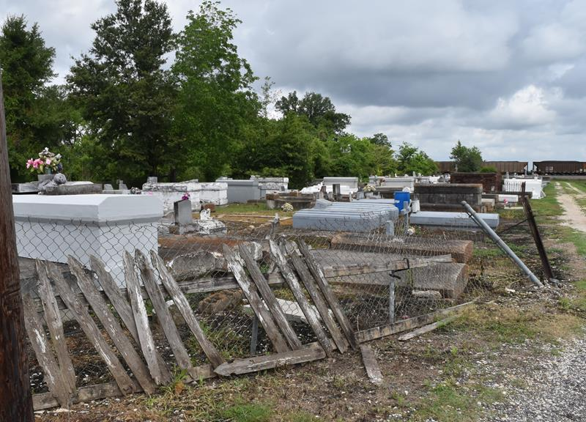

In loving memory of Jarvis D'Wayne O'Neal, whose life illuminated the hearts of all who knew him.
Jarvis D'Wayne O'Neal was born in Monroe, LA on April 18, 1975, to the union of Jessie O'Neal and the late Juanita Ann Wallace. He passed away on April 28th, 2024 at the age of 49.
Jarvis was a graduate of Arthur Ashe Charter School of New Orleans, LA. He was a cherished resident at Louis S. Davis Developmental Center of New Orleans, LA until 2009. Jarvis was a member of First Community Antioch Baptist Church under the nurturing leadership of the late Reverend Ferdinand Gaines, Jr. Jarvis was often seen enjoying worship service from the balcony while being accompanied by his loving mother, Sis. Juanita Wallace. He found solace and community within the church's embrace.
Jarvis enjoyed life's simple pleasures—car rides, indulging in pork n beans, potato salad, sweet potatoes, and the comfort of foot rubs. His love for music was surpassed only by his delight in spending quality time with his beloved family. Jarvis's enthusiasm for life was infectious. He eagerly attended gatherings, always with a hopeful eye for the promise of cake and ice cream. Jarvis leaves behind a legacy of love and cherished memories.
He is survived by his father, Jessie O'Neal; devoted brother Jared O'Neal, Sr. He was also adored and cherished by his nephews and nieces; Jared Jr., Jayce, Jaide, and Jardyn. His extended family includes his aunts; Audrey Mae (Earl) White and Yvonne Stewart, his devoted cousins; Terence (Marvis) White Sr, Charmaine White, Kimberly (Sampson) Duplessis, Normetric, Bry'An, China, De'Andre, and D'Nyri Storks, De'Juene, Jyri, and Chase Turner, Darrington and Darri'Yonne Anderson, Keisha (Alberto) Mosqueda, Atlantis Adedipe, Terence (Ebony) White Jr, Jyron and Jydell White, Austyn Williams, Solomon and Seven Mosqueda, and Samuel Adedipe. Devoted caregivers; Tessa Turner, Normetric Storks, Brenda Davis, and his North Exchange Alley family. Devoted friends Jerrod Turner, Jalen Johnson, and Milton Albert.
Jarvis was preceded in death by his beloved mother, Juanita Ann Wallace, maternal grandparents Mary Schofield Wallace and Camille Jack Wallace, Aunt; Jacquelyn W. (Norman Sr.) Storks Cousins; Norman A. Storks Jr. and Derrick D. Storks. Their spirits welcome him with open arms with an eternal embrace.
As we mourn Jarvis, let us also celebrate the beautiful life he lived—a life filled with love, laughter, and a gentle spirit that touched us all. Though he may no longer walk beside us, his memory will live on, a testament to the enduring power of love and the beauty of a life well-lived.
A Celebration of Life honoring Jarvis will be held on Saturday, May 11, 2024, at First Community Antioch Baptist Church, 10860 LA-3125, Lutcher, LA 70071. Visitation beginning at 9AM with services to follow at 11AM. Interment at Antioch Cemetery.

Treasures of Life Funeral Services, Gramercy, Louisiana

