Sandy Stephen Scott
March 1, 1966 – August 14, 2024

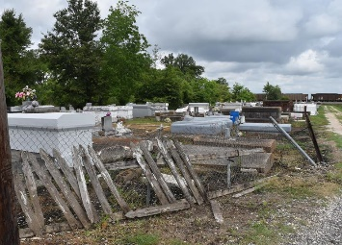

Sandy Stephen Scott a resident of Gramercy, LA, was born on March 1,1966 and departed this life on August 14, 2024, at 7:47 p.m. at East Jefferson hospital. Sandy was born to the parentage of Ferrel Charles and Marion Anderson Scott, Sr. He was the sixth of nine siblings born to this union. He was blessed to be loved by two brothers: Ferrel Jr. and Dana and six sisters: Robin, Laura, Charnell, Deanne, Tracey, and Kristi.
Sandy was strong-willed; he did whatever he wanted to do whenever he wanted to do it. He received his education through St. James Parish School System. He possessed a strong work ethic. He worked several jobs and was a very dedicated worker. Sandy was courageous throughout his battle with illness; he never allowed his illness to hinder his progress. While recovering from surgery in 2019 at East Jefferson Hospital, Sandy accepted Christ as his Personal Savior and became a member of Lutcher Chapel United Methodist Church under the leadership of Pastor Alton Preston. Sandy fought a good fight, not always easy, not always feeling good, but he kept the faith and continued to be strong and courageous.
He loved his family and enjoyed family gatherings, he enjoyed being with his friends and coworkers also. He enjoyed life, the way he knew how. Sandy also cherished the care and treatment he received when visiting his doctor. His physician, Dr. Sudhir K. Julka always said, “Sandy is a good guy”. Sandy will be truly missed by many who encountered him as he walked and drove daily throughout the community. His smile, his patience, and his perseverance will be remembered by all he encountered.
He leaves to cherish his memories, siblings: Robin (Ronald)Raphael, Charnell, Ferrel Jr., Kristi, and Dana Scott, nieces: Lamara (Juan) Johnson, Lavintia Doss, Caitlyn Scott, nephews: Chivas Scott, Vernon Lee Jr., Mason Scott, Darmeny Scott, and Donald Fleming, Jr., a host of great nieces, nephews, aunts, uncles, cousins and friends.
Sandy was preceded in death by his mother Marion Anderson Scott, father Ferrel Charles Scott Sr., sisters: Laura Lee, Tracey Fleming, and Deanne Scott, niece, Destiny T. Scott and brother-in-law, Vernon Lee Sr.
A celebration of life and legacy in his honor will be held on Saturday, August 24, 2024 at Lutcher Chapel United Methodist Church, 2290 Exchange Alley, Lutcher, La 70071. Viewing will begin for 10:00AM followed by service for 11:00AM. Rev. Willie Laws officiating. Final resting place, First Community Antioch Missionary Baptist Church Cemetery; Paulina La.

Treasures of Life Funeral Services, Gramercy, Louisiana

