Herman Williams
Unknown - May 13, 2019
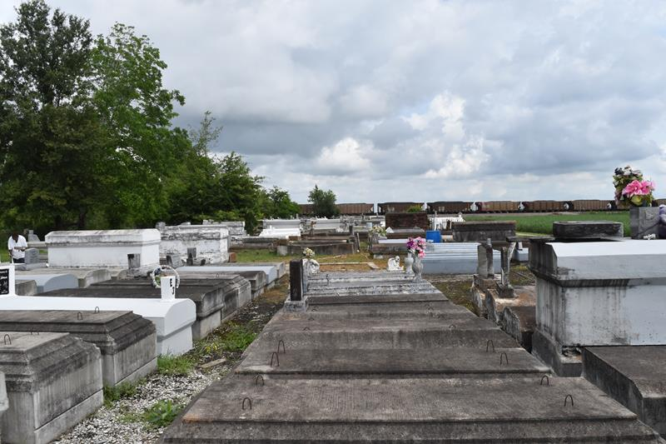

Herman Williams departed this life on Monday May 13, 2019.
Herman is survived by a host of relatives and friends.
Funeral Service on Saturday May 25, 2019 at 11 am at King David B.C.2329 King Ave. Lutcher, La 70071 Rev. Ferdinand Wallace Officiating. View is at 9 am until service time. Interment in CFBA cemetery Paulina, La.
Professional Services entrusted to the caring staff Hobson Brown Funeral Home, 134 Daisy St., Garyville, La 70051, (985) 535-2516.

The New Orleans Advocate, Louisiana
May 23 to May 25, 2019

