Octavia (Carter) Williams
November 9, 1949 – March 23, 2025

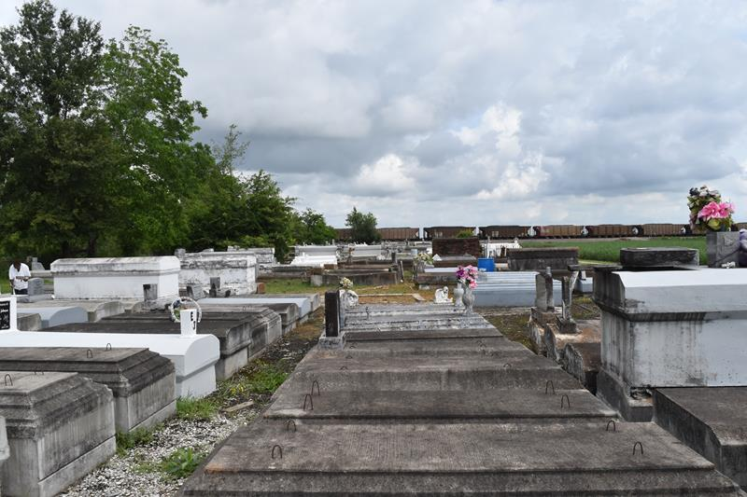

The Life Of Sister Octavia Williams

I was born to Sam and Mary C. Carter on November 9th 1949. I had seven siblings. James Woods Senior, Gloria Barney, Geraldine Pittman, Elizabeth Banks, Mavis Mitchell (William Mitchell), Walter Carter, and one devoted sister in law Mary Joseph. I had two children, Ineak and Garland Williams (Tonjia Taplin). I also had one grandchild, Kale Williams and two bonus grandchildren, Aaron Taplin and Paul Taplin.I had a host of cousins, nieces and nephews who I loved dearly and enjoyed being with. I loved my family. I had a list of Godchildren, Draque J Pittman, Mark Russell, Tessa Turner, Charlotte M Jones. I was the God child of Mavis P Fobb, who I love and miss dearly. I was preceded in death by my parents and three of my siblings, James Woods Sr, Gloria Barney, my baby brother Walter Carter and my devoted sister in law Kim D Carter.
I accepted Christ at an early age and I was a devoted member of Antioch Baptist Church under the late Ferdinand Gaines, Jr., where I served on the usher board. And I took my duties very seriously; no one would be chewing gum on my watch, I didn't care who you were. I was coming with that napkin. I was a good person but sometimes misunderstood, I loved my family and I enjoyed being around them. I never met a stranger because I embraced everyone with open arms, I was well known because I was myself, I said and did whatever I wanted to. Don't worry about me, I am in good company.
I ask that you pray for strength for my children Ineak and Garland, and my grandchildren: Kale, Aaron, and Paul. Thank you to my friends, Barbara Lagrange, Alton Breyer, Audrey White, Desus Webber, Joyce Jacques, Bertha Williams, Youlander J Williams, Jance Bourgeois and her sister Patricia, Patricia P Johnson.
Special thanks to my community, Latasha Brown, Judy Favorite, Tarasha Collins and anyone who helped me when I asked. Thank you for being patient and kind to me.
The family would like to invite family and friends to a public visitation on Thursday, April 3, 2025 at Treasures of Life Funeral Services, 315 E. Airline Hwy., Gramercy, LA 70052 from 3pm-5pm. A celebration of life, love, and legacy will be held on Friday, April 4, 2025 at First Community Antioch Missionary Baptist Church, 10860 Hwy. 3125, Lutcher, LA 70071. Visitation is for 10am followed by the service for 11am. Interment Antioch Church Cemetery, 3279 Antioch St., Paulina, LA 70763.

Treasures of Life Funeral Services, Gramercy, Louisiana
April 1, 2025

