Clarence Davis, Sr.
May 24, 1940 – August 3, 2023

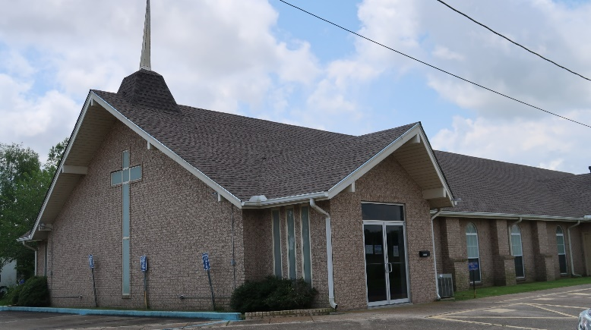

Clarence Davis, Sr., was born on May 24, 1940 to the union of the late Frank and Cecile Stewart Davis, Jr. He was one of five siblings; the late Kelson, Thomas, and James, Sr. (Theresa) Davis, and late Shirley Davis Washington. He was educated in St. John Public School System, and later attended Fifth Ward High School.
On Thursday, August 3, 2023, God saw that his child was restless and called him home from “Labor to Reward”, with his loved ones right by his side. He was 83 years old. Clarence married his first wife, Verlina “Gayle” Scott and to this union seven children were born, daughter; Joann “Mama Jo” (Peter, Jr.) Pierre, and Cardell (Raymeker); Laplace, LA, Clarence Jr. (Donna); Baton Rouge, LA, Vincent (Dianne); Garyville, LA, and Quincy (Shawanda) Davis of Gonzales, LA, and the late Herman “Pep” Davis, Sr., and Michael Lawrence Davis, Sr., daughters; Janet Isom (Perry) Landor; Laplace, LA, and Virginia (Mister) Nelson, of Cocoa, FL. He met and married his second wife, the late Rebecca Davis and helped rear a step-son, Lindsey Anderson III. Clarence was blessed to have 42 grandchildren, 62 great-grandchildren, and 1 great great-grandchild. He also had a bonus daughter, Bridget Williams.
Clarence gave his life to Christ at an early age. He was baptized by the late Rev. Forest Green at New Hopeful Baptist Church, Garyville, LA. In his later years, Clarence attended Mt. Zion Baptist Church #1, Garyville, LA; Pastor Henry Robinson, and later joined True Light Baptist Church, Garyville, LA under the leadership of Pastor Sam Jones, III.
Clarence loved his family dearly and was a great provider to them. During his lifetime, he worked daily to make sure all his family’s needs were met. That included employment at Pittman Construction; 15 years, Payne and Keller Construction; 7 years, and BE&K Construction; 23 years. He later retired and began enjoying the fruits of his labor.
Clarence leaves to cherish his precious memories his loving family; children, Joann (Peter) Pierre, Jr., Clarence (Donna) Davis, Jr., Vincent Davis (Dianne), Cardell (Raymeker) Davis, Quincy (Shawanda) Davis, Janet (Perry) Landor, and Virginia (Mister) Nelson, sisters and brothers-in-law; Geraldine (Stanley) Eugene, and Walter (Gloria) Scott, Wilmore, Joy, along with a host of nieces, nephews, cousins, other relatives and friends. He was preceded in death by his parents; Frank and Cecile Davis, Wives; Verlina Davis, and Rebecca Davis, sons; Herman Davis, Sr., Michael Davis, Sr., and grandson; Juan “Po Larry” Bolden, Brothers and Sister; Kelson, Thomas, James (Theresa) Davis, and Shirley Davis Washington, Mother and Father-in-law; Leona Smith and Herman Scott, Sr., sister and brothers-in-law; Patricia S. Parilla, Herman, Jr., Raymond, and George Scott.
A public visitation will be held on Friday, August 11, 2023, at Treasures of Life Funeral Services, 315 E. Airline Hwy., Gramercy, LA 70052 from 3:30PM-5:30PM. A celebration of life honoring Clarence Davis, Sr. will be held on Saturday, August 12, 2023, at True Light Baptist Church, 258 S. Little Hope St., Garyville, LA 70051. Visitation will be held from 9AM-11AM. Service will begin at 11AM. Interment to follow at Buena Vista Baptist Church Cemetery in Lemonville, LA.

Treasures of Life Funeral Services, Gramercy, Louisiana
August 13, 2023

