Florestine (Mitchell) Adams
February 28, 1900 – March 15, 2000

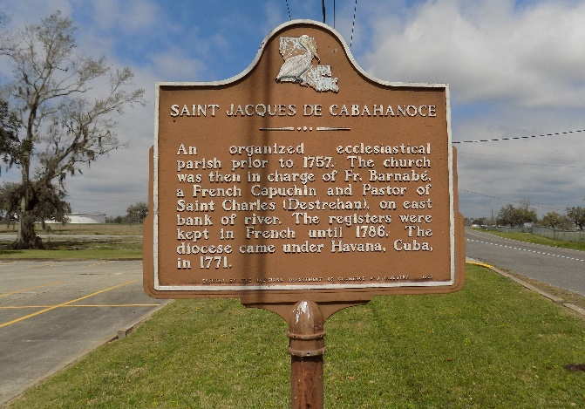

Florestine (née Mitchell) Adams was born in Hymel, Louisiana (present day St. James, La.) to Choctaw and Louisiana Creole parentage. Florestine was the daughter of Elfére Mitchell and Sidonie, a native Louisiana Creole. Briefly educated in St. James Parish; Florestine left Southeast Louisiana for North Texas. There, she gained employment as a maid, but eventually her culinary and event management skills placed her in great demand. Business opportunities expeditiously found her. She married C. Adams.
Upon the death of her husband, Florestine retired and returned to her hometown of St. James, Louisiana. There, she served as a pillar to the Freetown - St. James, and St. James Catholic communities and became the primary caretaker to her mother who became blind, and was an advocate for St. James Parish's 5th district senior residents.
Mrs. Adams tithed a portion of her earnings to St. James Catholic Church and generously donated to the Catholic Diocese, Catholics Charities, and non-profit organizations geared towards education and emergency aid. Even in death, Florestine Adams' legacy of giving was illuminated. As a humanitarian gesture to support the advancement of medical education, research and technology; Florestine donated her organs and body to the Bureau of Anatomical Services.
At the time of her death, she was the eldest resident of the historic Settlement of Freetown community, the eldest member of St. James Catholic Church, The Rising Sun Benevolent Association, St. James Parish's Senior Citizens Center-Welcome Park, and the eldest registered anatomical donor in St. James Parish.

Official Website
Accessed 1/27/2025

