Joseph Ambrose Sr.
May 22, 1915 – June 7, 1998

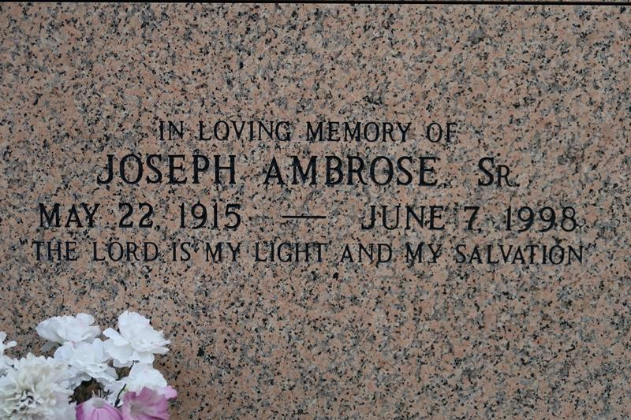

Joseph Ambrose, Sr. of St. James, LA at Columbia Dixon Medical, Baton Rouge, LA on Sunday, June 7, 1998 at 3:00 pm. Beloved husband of Mrs. Florestine Jane Ambrose, Son of the late Louis and Louise Ambrose. Beloved father of Jerralyn Ambrose-Clark, Joyce A. Hazelwood, Janice M. Roussell, Joseph Ambrose, Jr., J. P. Ambrose, Jules A. Ambrose, Sr., Jeffery A. Ambrose Sr. and the late Louise Ambrose. Brother of Lawrence Ambrose, Sr. and the late Lebora and Louis Ambrose, Jr. Also survived by 35 grandchildren, 23 great grandchildren, a host of nieces, nephews, sisters and brothers-in-law, daughters and sons-in-law, cousins and friends. A native of Vacherie and a resident of St. James, LA. Age 83 years.
Relatives and friends of the family, also priest and parishioners of St. James Catholic Church, St. Phillip Catholic Church, Crowder Church of Christ. St. Luke B.C., First Baptist Church, Highway B.C. and neighboring churches, members of Friends of Faith Society, American Leion Post 565 – Vacherie, employees of the US Navy, Amedysis, Sunshine Home Health, Capital Home Health, 1846 Carpenter Local, Local No. 60, Union Carbide, U.S. Postal Dept. – N.O, Orleans Parish School System, St. James Parish School System, Occidental Chemical, Chevron Chemical, are invited to attend a Mass of Christian Burial on Friday, June 12, 1998 at 11:00 am from the St. James Catholic Church, St. James, LA. Father Howard Hall, celebrant. Entombment church mausoleum. Visitation at the church after 9:00 am. Recitation of the rosary at 9:30 am. NO WAKE. Earl Baloney & Sons in charge of arrangements.

Unknown newspaper clipping

