Louis John Ambrose

August 5, 1954 - December 24, 2018

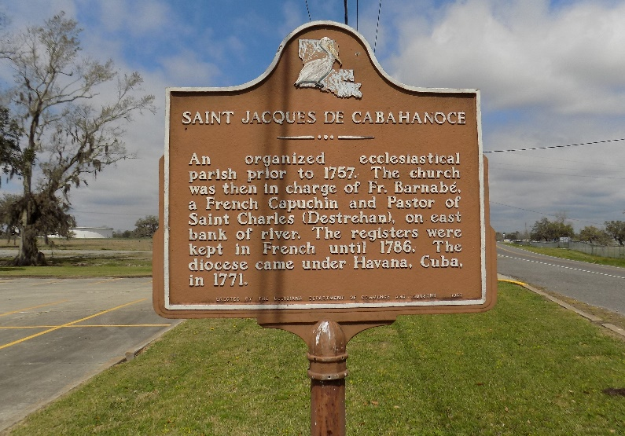

Louis John Ambrose, aka “JOHNBOY” was born AUGUST 5, 1954 in Charity Hospital, New Orleans, Louisiana, to Joseph Ambrose, Sr., and Florestine Mayho Ambrose. Louis was born a twin, but his sister Louise did not survive. As a baby Louis was baptized, received First Communion and Confirmation at St. James Catholic Church. Louis attended Cedar Grove Elementary, Magnolia and St. James High School, Xavier University of Louisiana and Southern University, Baton Rouge, Louisiana. Louis was a lifelong resident of St. James, Louisiana until moving to his home in La Place, Louisiana.

Louis is survived by his devoted children Kendall Ambrose, John Ambrose, Jr., Delisha Holmes and Sherell Holmes, former wives Annette Narcisse and Melissa Stamps Ambrose. A consummate father, brother, uncle, grandfather, cousin, co-worker, and friend.

He enjoyed family, friends, all sports, traveling, telling jokes, laughing, soaking up the sun on the Lake Front and entertaining at home. He is known for his radiant and electrifying smile and loving personality. He loved reading his bible and was a “Born Again Christian”. He had superior knowledge, always giving wisdom-filled advice to all, and was blessed to have many, many friends. Everyone enjoyed being around Louis because he had such a sunny outlook on life and sense of humor. No matter how bad a situation seemed Louis had a wit about him that made us all smile!

Louis was preceded in death by his parents, Joseph Ambrose, Sr., and Florestine Mayho Ambrose, his brother Joseph Ambrose, Jr., and twin sister Louise. SURVIVED by his children, Kendall (Anessa) Ambrose, John (Najee’) Ambrose, Jr., Delisha Holmes, and Sherell Homes. He’s also survived by his grandchildren, Kalana, Aden, Jaiden, Jailen, Taelyn, Sa’Myra , Alayah, and Markayla; 7 brothers; James P. Ambrose (Maxine) of St. James, Louisiana, Jules Ambrose of New Orleans Louisiana, Jerome Ambrose (Loletia) of St. James Louisiana, Jesse Ambrose of New Orleans Louisiana, Joshua Ambrose of St. James Louisiana, Jacob E. Ambrose (Patrice) of Lafayette Louisiana, and Jeffery Ambrose, Sr., of New Orleans Louisiana. Three sisters; Jerralyn Bazile (Elvin) Harvey, Louisiana, Joyce Hazelwood of Moreno Valley, California and Janice Roussell (Dwight) of Palm Coast Florida. Also, a host of nieces and nephews who were profoundly crazy about their uncle.

Louis was a very special person, who was generous in spirit, full of empathy, prone to sentimentality and an affectionate heart. One of the hallmarks of his life was an immaculate lawn for himself and his neighbors. He never saw a dirty car that he would not wash. For all of us who shared our special secrets and concerns with Louis can still confide in him, because he’s definitely one of GOD's Angels!

Mass of Christian Burial will be held on Friday, January 4, 2019 from St. James Catholic Church, 6613 LA 18, St. James, LA 70086. Visitation 9am followed by 11:00 am service. Father Brad Doyle, Celebrant. Interment church cemetery.

Treasures of Life Funeral Services, Gramercy, Louisiana