Geraldine Cecile (Scieneaux) Bailey
January 13, 1953 – August 10, 2024

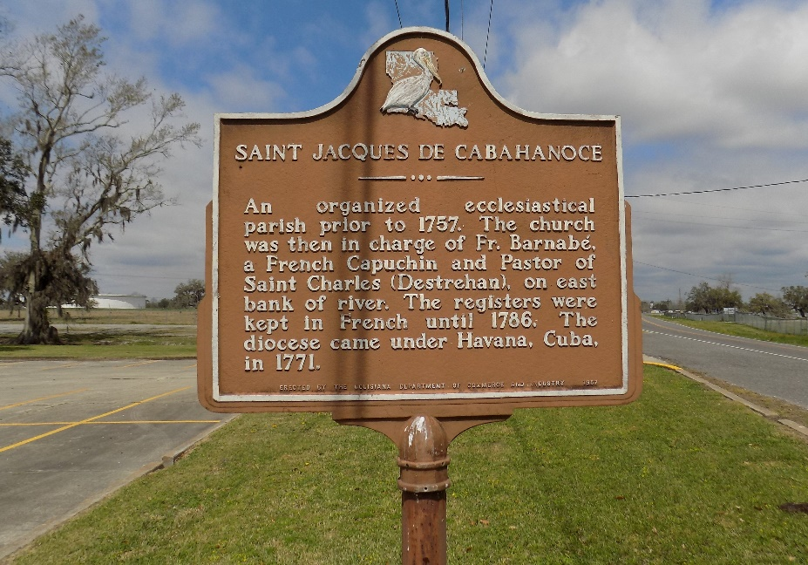

Geraldine Scieneaux Bailey, A beautiful sacrificial life came to an end on Sunday, January 2, 2005.
A native of St. James and a resident of Donaldsonville, she died peacefully in her sleep at her residence at the age of 71. She was a retired school teacher in St. James Parish with 38 years of services. Visiting at St. Catherine of Sienna Catholic Church, 421 St. Patrick St., Donaldsonville, LA., Saturday from 9:00 AM until Mass of Christian Burial at 10:00 A.M. conducted by the Rev. Patrick Otor, MSP. Interment in St. James Catholic Cemetery, St. James.
Survived by her mother, Velener Nelson Scieneaux of St. James; a daughter Cynthia Bailey Jackson of Baton Rouge; a son, Dr. Lloyd E. Bailey of New York City; two grandchildren: Ashley Angelle Bailey and Alexander Taylor Rideout; a son-in-law Jonifer Jerome Jackson, Sr.; three sisters and their spouses: Lillie Mae and Harold Preyan, Caldonia and Rev. Felton Ceasar, Mae Francis and John Oubre; and a sister-in-law Shirley H. Scieneaux; three brothers and their spouses, Pearl, Jr., and Irene, Bearl and Delores, Herman and Connie Scieneaux, and a dearly loved aunt Velma Wallace of New York City.
Preceded in death by her husband Alton James Bailey, her father Pearl Scieneaux, Sr., and a dearly beloved brother Roy Scieneaux. BRAZIER-WATSON FUNERAL HOME IN CHARGE OF ARRANGEMENTS.

The Times-Picayune, New Orleans, Louisiana
Jan. 6 to Jan. 7, 2005

