Maldon Matthew Borne Sr.
1958 – September 7, 2013

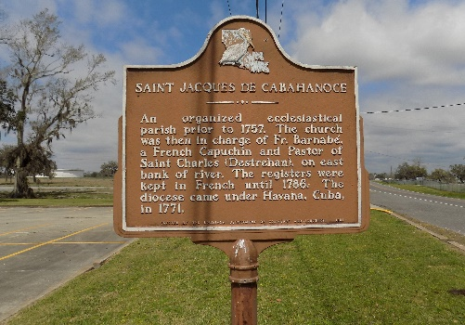

Maldon Matthew Borne, Sr., of Vacherie, LA, departed this life on Saturday, September 7, 2013, at the age of 54 years old. Son of Carrie Lee Borne and the late Christopher Borne, Sr. Father of Tameka, Lanaire, Meldon (Kawanna) Borne, Jr. and Kia Joseph. Devoted friend of Vanessa Joseph for over 23 years. Brother of Yvette (Renaldo), Jillandra (Melvin White) Borne, Valencia (Jerry) Colton and LeJeanne (Lionel) Luke, Christopher, Jr., Reginald, and the late Nialyn Borne. Also survived by a host of grandchildren, aunts, uncles, nephews, nieces, other relatives and friends.
Relatives and friends of the family, FABCO, Marybird Perkins Cancer Center, Our Lady of the Lake Medical Center, are invited to attend a Mass of Christian Burial on Saturday, September 14, 2013, for 11:00 a.m. at St. James Catholic Church, 6613 Highway 18, St. James, LA. Father Christopher Decker will be officiating. Visitation will be from 9:00 a.m. until time of service. Entombment in church cemetery.
The Times-Picayune, New Orleans, Louisiana
Sep. 10 to Sep. 13, 2013
**

Maldon Matthew Borne from tree ADAMS.FBK(1)(1)

Birth 15 May 1958 Vacherie, St James, Louisiana, USA
Death 7 Sep 2013 Vacherie, St James, Louisiana, USA
Father Christopher Decker Borne (1929-2000)
Mother Carrie Lee Jasmin (1940-2015)
2998 People 0 Records 0 Sources

