Michael Eugne Bouie
March 5, 1956 – January 21, 2022

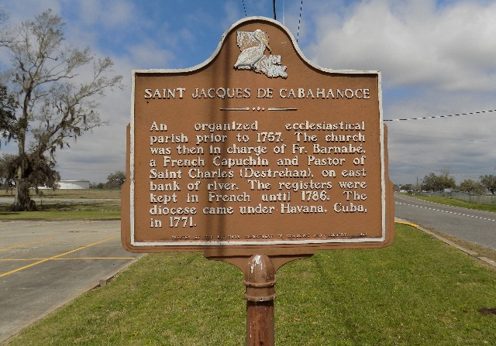

Michael Eugene Bouie, age 65, entered eternal rest on Friday, January 21, 2022. He was born on March 5, 1956, in New Orleans, LA.
He is preceded in death by his parents, Myrtle N. Bouie and Joseph Bouie, Sr.; 3 brothers, Warren, William, and Melvin Bouie; and nephew, Warren Bouie, II.
Michael is survived by his wife, Loretta Smith Bouie; 3 children, Lanier Bouie, Sr. (Diamonique), Miesha Bouie, and Kayla Leonard; 4 grandsons, Jeremiah, Lanier Bouie, Jr., Charles Barkins II, and Grey Hicks II; 3 granddaughters, Nyrianne and Brandie Bouie, and Jordan Coleman; 4 siblings, Sharon, Michelle, Lena, and Joseph Bouie; and a host of nieces, nephews, other relatives, and friends.
Relatives and friends of the family are invited to attend his Celebration of Life Service on Saturday, January 29, 2022, 11:00AM, at Mount Calvary Baptist Church, 8103 Mount Calvary Street, St. James, LA 70086. Visitation will be held from 10:00AM until the hour of service. Interment St. James Church Cemetery. Due to COVID-19 mandates, Masks are required.

Published on Legacy.com by Professional Funeral Services, New Orleans, Louisiana
Jan. 27, 2022

