Lucille (Hymel) Bye
March 16, 1923 – June 10, 2022

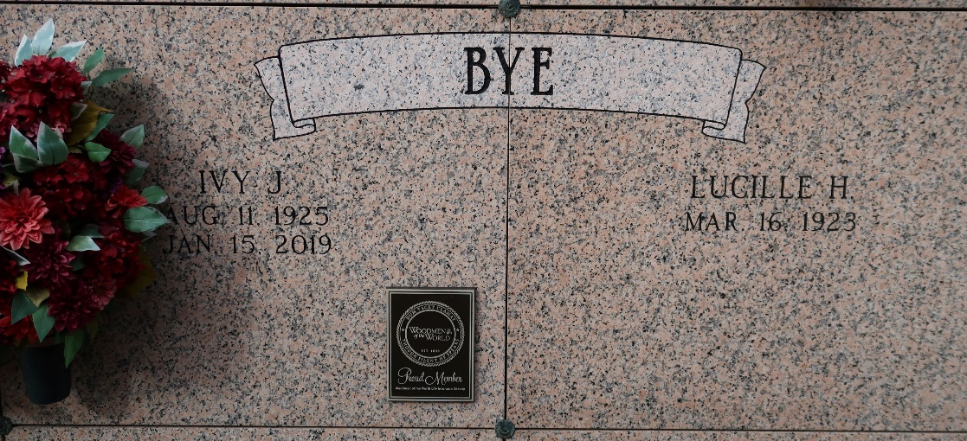

Lucille Cecile Hymel Bye, 99, a lifelong resident of St. James, Louisiana passed away on Friday, June 10, 2022. Lucille was born March 16, 1923.
Lucille was a loving wife, mother, grandmother, great grandmother, sister and friend. She loved cooking, baking, going to the casino, playing bingo and eating out with family and friends. Lucille had a special devotion to St. Therese, the Little Flower of Jesus and the Blessed Mother.
She is survived by her daughter, Barbara (Eugene "Tunny") Chauvin; sister, Marie Therese Gonzales; brother, Lloyd Hymel; 4 grandchildren, Leslie (Chris) Kimble, Rae Lynne (Casey) Amedee, Danielle Chauvin and Dean (Jennifer) Bye; 9 great grandchildren, Holden and Lily Amedee, Abigail and Harrison Kimble, Caleb, Dawson, Lexi, Cameron and Cloe Bye; brother-in-law, Lloyd "Peanut" Laurent; best friend, Mary Anne Granier.
Lucille is preceded in death by her husband, Ivy Bye; son, Gary (Connie) Bye; granddaughter, Shelly Bye; parents, George and Marie Hymel; brothers, George (Inez), Merlin (Martha), Nelson (Marie), Ivy (Martha) and Clifton "Kippy" (Doris); sisters, Eunice Hymel, Edith (Stephen) Laurent, Mabel (Luke "Duck") Granier and Amy Laurent.
Visitation will be held on, Wednesday, June 15, 2022 at St. James Catholic Church, St. James, LA from 11:30am until Mass of Christian Burial at 1:00pm. Rosary will be recited at 12pm. Interment will follow in the church cemetery.
In lieu of flowers, the family ask that donations be made to St. Jude Children's Research Hospital.
Special heartfelt thanks to Thibodaux Healthcare Center and Heart of Hospice of Thibodaux.

Ourso Funeral Home, Ascension Parish, Louisiana
Dignitymemorial.com

