Walter Anthony Cantrelle Jr.
1953 – April 24, 2024

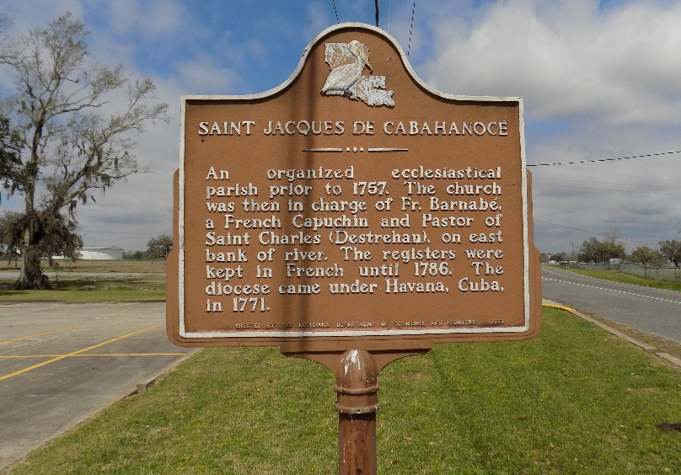

Walter Anthony Cantrelle, Jr. departed this life on Wednesday, April 24, 2024, at his residence in Gonzales, LA. He was 71, a native of St. James, LA.
Visitation on Friday, May 3, 2024, at Williams & Southall Funeral Home, 101 Loop 945 Donaldsonville, LA from 6:00pm to 8:00pm. Visitation on Saturday, May 4, 2024, at St. James Catholic Church from 9:00am to Mass of Christian Burial at 11:00am. Interment in the church cemetery.
Survived by 4 sons, Walter Cantrelle, III (Kim), Janc Napoleon, Shontrel Napoleon (Andrea), and Dontrel Napoleon (Ashley); a niece whom he reared, LaShae Dumas; 1 brother, Antoine Cantrelle, Sr.; 1 sister, Marilyn Cantrelle Jones (Jezerel); former wife, Angela Johnson Cantrelle; 24 grandchildren; a host of nieces, nephews, other relatives, and friends.
Preceded in death by his parents. Walter Cantrelle, Sr., and Marion Trepagnier Cantrelle; 1 son, Labaron Napoleon; 1 nephew, Antoine Cantrelle, Jr.; maternal grandparents, Sheridan, and Mary Trepagnier; paternal grandparents, Paul and Constance Cantrelle.

Williams and Southall Funeral Home, Donaldsonville, Louisiana

