Carrol Joseph Cayette Sr.
Unknown – April 10, 2023

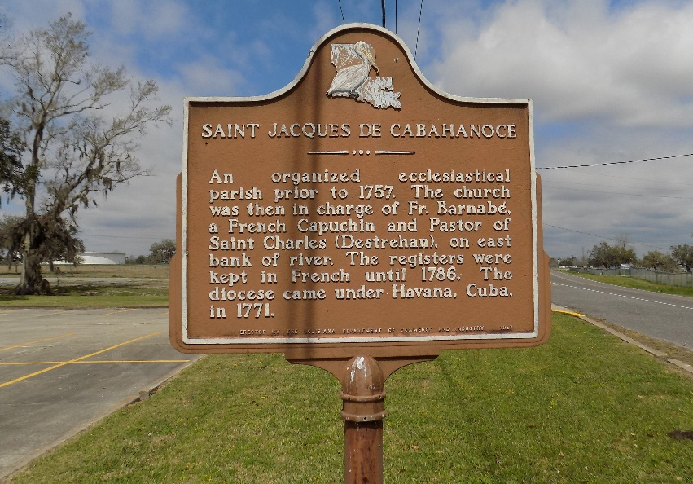

LTC (Ret.) Carrol Joseph Cayette, Sr. A U.S. Army veteran of War II, Korean War and Vietnam Conflict. An alumni of Southern University and member of Phi Beta Sigma Fraternity. He was loved and will be missed by family and friends.

Visitation Tuesday, April 25, 2023, 3:00 pm to 5:00 pm, Hall's Celebration Center, 9348 Scenic Highway, Baton Rouge, LA 70807. Visitation continues on Wednesday, April 26, 2023 10:00 am until Mass at 12:00 noon, St. James Catholic Church, 6613 Highway 18, St. James, LA 70086. Father Thomas F. Clark, SJ, officiating. Entombment St. James Catholic Church Cemetery.

Funeral Services entrusted to Hall Davis and Son. www.halldavisandson.com.
The Advocate, Baton Rouge, Louisiana
Apr. 21 to Apr. 24, 2023

