Frances Aldonia (Calvey) Cayette
November 25, 1926 – October 24, 2006

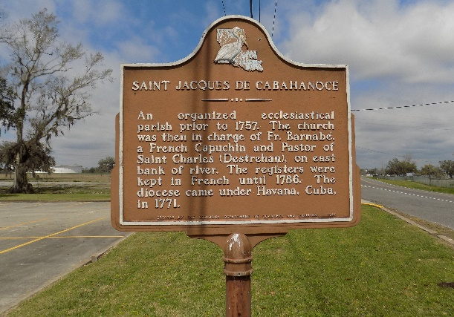

Frances Calvey - A native and resident of St. James, she died at 4:25 p.m. on Tuesday, Oct. 24, 2006, at Our Lady of the Lake Regional Medical Center in Baton Rouge.
Visiting will be at St. James Catholic Church, St. James, on Monday, Oct. 30, from 9:30 a.m. until Mass of Christian Burial at 11 a.m., celebrated by the Rev. Louis Oubre. Interment in the church cemetery.
She is survived by two daughters, Sharon Lavigne and Claretta Cayette; two sons, Milton Jr. and Robert Cayette Sr.; a daughter-in-law, Angela Cayette; 12 grandchildren, 11 great-grandchildren, numerous nieces, nephews, cousins, other relatives and friends.
She was preceded in death by her parents, Valmont Calvey and Clara Ried Calvey; her husband, Milton Cayette Sr.; two daughters, Marion and Charlene Cayette; and a sister, Osteal Washington.
Brazier-Watson Funeral Home of Donaldsonville is in charge of arrangements.
The Advocate, Baton Rouge, Louisiana
October 29, 2006
**

U.S., Social Security Applications and Claims Index, 1936-2007

Name Frances Aldonia Calvey
Gender Female
Race Black
Birth Date 25 Nov 1926
Birth Place Welcome, Louisiana
Death Date 24 Oct 2006
Father Valmond J Calvey
Mother Clara Reid
SSN xxx
Notes Jun 1944: Name listed as FRANCES ALDONIA CALVEY; Aug 1948: Name listed as FRANCIS CALVEY CAYETTE; 27 Nov 1990: Name listed as FRANCES ALDONIA CAYETTE; 01 Apr 1991: Name listed as FRANCES A CAYETTE

