Joseph Ernest Cayette Jr.
October 25, 1939 – March 19, 2015

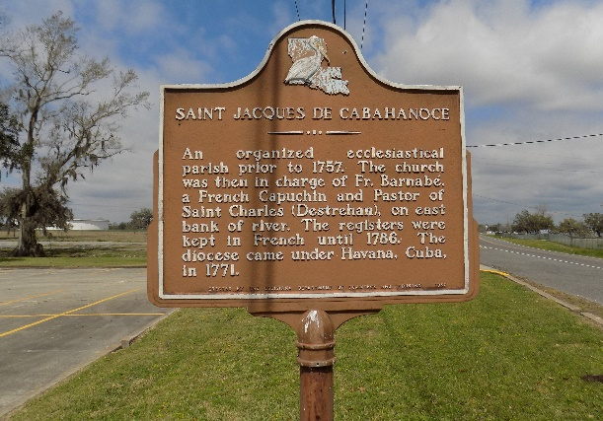

Joseph Ernest "Tony" Cayette, Jr. departed this life on Thursday, March 19, 2015, he was 75. Devoted husband of Dianna Oubre Cayette. Son of the late Ernest Cayette and Celeste Johnson. Loving father of Deneen (Mervin) Antoine, Maya (Datren) Williams, and Jada (Gerald) Singleton. Proud grandfather of Daven, Darren, Dillen, Gerald, Jr. and Callie. Brother of Claudette Octave, Lorraine Mitchell, and the late Leroy Cayette and Dorothy Raymond. Nephew of Oralee Ferchaud and Harold Cayette. Also survived by a host of sister-in-laws, brother-in-laws, nephews, nieces, cousins, other relatives and friends.
Relatives and friends are invited to attend a funeral mass at St. James Catholic Church, 6613 Highway 18, St. James, LA, on Monday, March 23, 2015, for 11:00 a.m. Visitation will be from 9:00 a.m. until time of service. Father Christopher Decker will be officiating. Interment will be at St. James Catholic Church Cemetery, St. James, LA.
The New Orleans Advocate (LA)
Mar. 21 to Mar. 23, 2015
**

Joseph Ernest Cayette from Clark Jr Hawthorne West Jones Quivers Family Tree

Birth 25 Oct 1939
Residence 1993 Vacherie, St James, Louisiana, USA
Death 2015
Father Ernest Cayette !# (1912-1989)
Mother Celeste M Ferchaud (1911-1991)
212059 People 4 Records 4 Sources

