Kristie Marie Cayette
August 8, 1974 – January 26, 2006

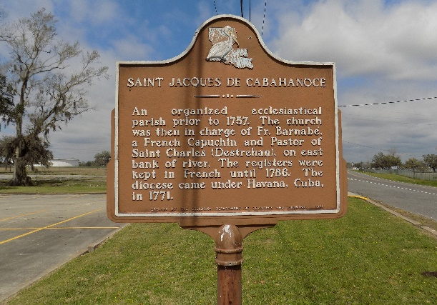

Kristie Marie 'Gert' Cayette, age 31, a native of New Orleans, died in Baton Rouge, LA. on Thursday, January 26, 2006.
She is the beloved daughter of Cassandra Smith Frederick and Amedee Mark 'Swag' 'Tramp' Cayette. Stepdaughter of Ricardo Frederick. Adoring mother of Christopher, Shawne and Anderson Cayette. Loving lifelong companion of Anderson Soco. Sister of Dawn Cayette White, and the late Mark 'Duck' Cayette. Stepsister of Tracy Frederick Williams and Melanie Frederick. Sister- in-law of Therence J. White, Jr., and Lavonzell Williams and Lionel Williams. Granddaughter of James and Dolores Roberts, Edna Scovell Smith and the late Charles Smith. She is also survived by a host of loving aunts, uncles, nieces, nephews, cousins and friends.
Relatives and friends are invited to attend the funeral services at D. W. Rhodes Funeral Home, 2929 Scenic Highway, Baton Rouge, LA, on Saturday, February 4, 2006, at 10 a.m. Visitation from 8 a.m. until service time. Interment in St. James Cemetery, Vacherie, LA.
Times Picayune, New Orleans, Louisiana
February 3, 2006
**

Kristie Cayette from tree *My Family Tree

Birth 8 Aug 1974 New Orleans, Orleans, Louisiana, USA
Residence 1996 New Orleans, Orleans, Louisiana, USA
Death 26 Jan 2006 Baton Rouge, East Baton Rouge, Louisiana, USA
Father Amadee Cayette (1948-2006)
Mother Cassandra Marie Smith (1952-2018)
15696 People 2 Records 2 Sources

