Willie Celestin Jr.
January 18, 1924 – March 22, 2001
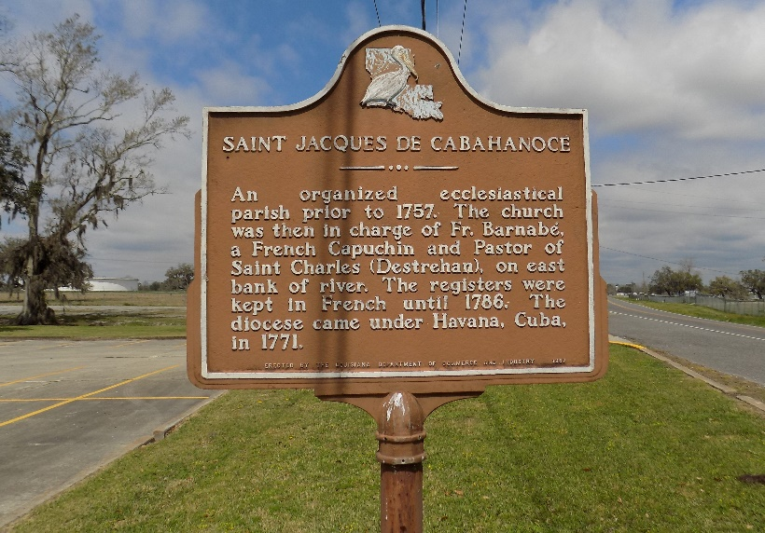

CELESTIN ST. JAMES – Willie “Dollin” Celestin Jr., 77, a native and resident of St. James, died March 22. He was the husband of Edna Saul Celestin and father of Shavvone Schonberg, Teresa Harris, Miguelle Meno, Colleen Joseph, Gretchen Williams, Faith Lathers and Brettaiene, Walter, Andrew and Michael Celestin. He was also the son of the late Willie Sr. and Elenora Celestin and brother of Ethel Knight and Horace and the late Louis and Lionel Celestin Sr. He is also survived by 24 grandchildren and seven great-grandchildren. He was preceded in death by one grandchild.
Services were March 27 at St. James Catholic Church, St. James, with interment at the church cemetery.

L’Obervateur, LaPlace, Louisiana
March 28, 2001
**

U.S., Social Security Applications and Claims Index, 1936-2007

Name Willie Celestin Jr
Gender Male
Race Black
Birth Date 18 Jan 1924
Birth Place St James Par, Louisiana
Death Date 22 Mar 2001
Father Willie Celestin
Mother Elnora Tassin
SSN xxx
Notes Sep 1941: Name listed as WILLIE CELESTIN JR; 11 Apr 2001: Name listed as WILLIE CELESTINE

