Lawrence Champagne Jr.
1973 – April 17, 2003

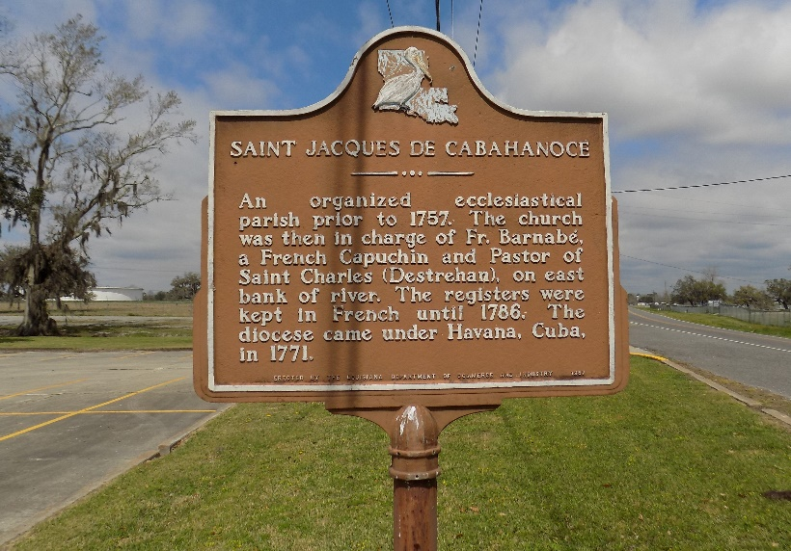

Lawrence (Rock-A-Dome) Champagne, Jr. of Vacherie, LA, passed away on Thursday, April 17, 2003.
Son of Lawrence Champagne, Sr. and Laura Mae C. Davis. Father of Tyrese Tyler Champagne and Azendi Joseph. Brother of Monica and Preston Champagne. Uncle of Keiosha Sutherland. Also survived by 3 Godchildren, aunts, uncles, cousins and friends. A native and resident of Vacherie, LA. Age 29 years.
Relatives and friends of the family; also priest and parishioners of St. James Catholic Church, Woodville B.C. and neighboring churches; employees of Cajun Industry, Dow Chemical and Basic Industry are invited to attend the Funeral Services on Wednesday, April 23, 2003, at 11:00 a.m., from the St. James Catholic Church, St. James, LA. Father of Louis Oubre - celebrant. Interment in the Church Cemetery. Visitation at the Church after 8:00 a.m. Recitation of the Rosary at 10:00 a.m.
BALONEY FUNERAL HOME in charge of arrangements.

The Times-Picayune, New Orleans, Louisiana
Apr. 22, 2003

