Charles Joseph Dennis III
September 1, 2000 – July 17, 2024

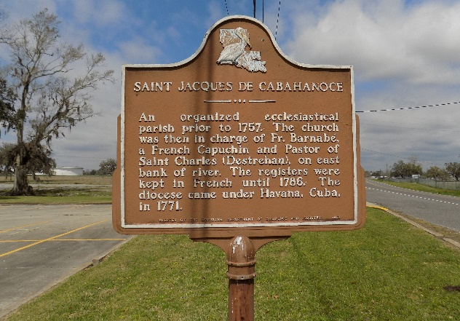

Charles “Chuck” Joseph Dennis III, a resident of Dallas, TX, a native of Vacherie, LA, was born on September 1, 2000, at Woman’s Hospital in Baton Rouge, LA. Charles III was the precious son of Charles Jr. and Meeka Meggs Dennis. Charles was baptized into the Catholic faith at an early age at St. James Catholic Church under the priesthood of Father Louis Timothy Oubre. Charles “Chuck” Dennis III was educated in St. James Parish Public School System. He was a graduate of St. James High School, Class of 2018. Chuck was awarded a full scholarship from the world-renowned Southern University’s Human Jukebox Marching Band, in addition to receiving TOPS University Award from the state of Louisiana. After joining the Jaguar Nation, he graduated from Southern University A & M College in Baton Rouge, LA, in 2022, acquiring a B.S. in Accounting. At his time of passing (7/17/2024), Charles III was pursuing his MBA in accounting at Texas Wesleyan University.
Charles was employed at Eagle Materials, as an accountant in Dallas, TX. Prior to joining Eagle Materials, he was employed by Ernest & Young U.S. LLP Firm. Chuck had a passion for music! At an early age Chuck was introduced to the saxophone by his dad. That’s when Chuck found his niche. He had been playing the saxophone since the 5th grade. Although he was taught by many teachers, his love for music was driven into him by his father. The two of them would often battle each other playing their saxophones in the living-room, but his dad would often get short winded. The two of them would practice marching drills, musical scales, and share secrets about their experiences with The Human Jukebox.
Chuck was also the jokester of the family! He would send funny videos all day and every day. When momma would fuss at the others, Chuck would eliminate the tension in the room with a joke. The bond he shared with his sibling was unbreakable. Chelsea and Joy were his road dogs, and Camrin and Shane were his protectors.
Charles III leaves to cherish wonderful memories his parents, Mr. & Mrs. Charles Dennis, Jr., 4 siblings: Chelsea Dennis, Joy Grows, Camrin Grows, Shane Grows; grandparents: Charles, Sr. and Leona Allen Dennis; Aunts: Cassandra (Cassie) Oubre, Taraline Dennis (Godmother), one Uncle: D’Antoni Dennis (Shantell); Cousins: Ja’Naija Dorris Striggs (Kawaun), Ricky Green (Darilyn), Chase Green (Braedi), Kylon Green (Breonna), Kaiden Dennis, Kacie Dennis, Landon Dennis, Diamond Dennis (fur baby), and Saint Laurent (fur baby); Godfather: Marlon Dennis; and a host of other relatives and friends.
Charles III, is proceeded in death by his maternal grandparents: Albert and Brenda Meggs; Aunts: Trina Meggs Dorris and Shanell Meggs; maternal great grandparents: Juanita Joseph Stewart, Howard Joseph, Rev. Joshua Stewart, Warren Meggs, and Francis Plant Meggs. Paternal great grandparents: Austin Dennis, Sr., Alma Treaudo Dennis, Thomas Allen, Sr. and Celestine Scieneaux Allen.
A gathering of family and friends will be held on Friday, July 26, 2024 from 4-6 pm at Treasures of Life Funeral Services, 315 E. Airline Hwy, Gramercy, La 70052. A celebration of life will be held on July 27, 2024, at St. James Catholic Church, 6613 Hwy. 18, St. James, LA 70086. Visitation begins at 8:00am, Holy Rosary at 9:00am, Memorial Tribute at 9:30am, and Christian Mass at 10:30am. Fr. Mike O’Rourke celebrant. Interment to follow at St. James Catholic Church Cemetery. Repast at Rose’s Catering, 10141 Frontage Street, St. James, LA 70086.

Treasures of Life Funeral Services, Gramercy, Louisiana
July 26, 2024

