Roberta (Gauthreaux) Duronslet
September 22, 1946 – November 4, 2021

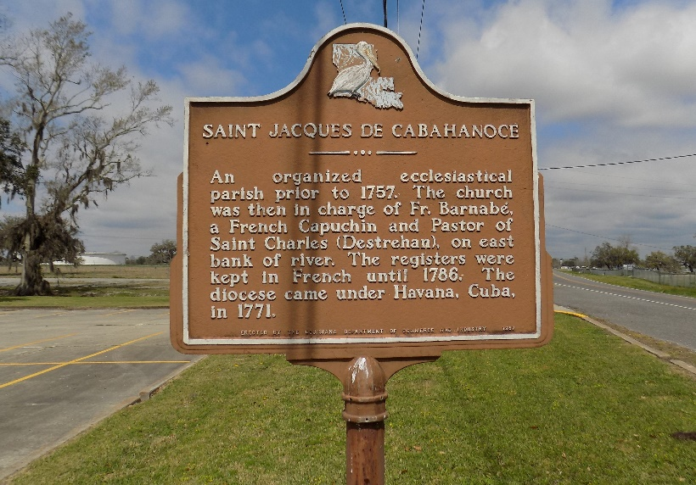

On Thursday, November at 6:00 pm, Roberta Duronslet departed this life. She was born and raised in Welcome, LA to Ulysses Sr. and Florence Geason Gauthreaux. She leaves to cherish her memory 3 children: Nicholle (Vincent) Bridgewater, Joel Duronslet, Jr., and Dennis (Katicka) Duronslet, Sr; 4 grandchildren: Ciera (Johuan) Gasery, Dennis Duronslet, Jr., Jireh Webster, and Airien Simoneaux; 4 great grandchildren: Aschere and Dominic Gasery, Maci Duronslet, and Aubri Semien; 4 sisters: Wilhemina Landry, Mable Gauthreaux, Geraldine Dickerson, and Florence Harvey; 2 brothers: Edward (Gloria) Gauthreaux, Sr. and Ronald (Denise) Gauthreaux, Sr.; and 2 sister-in-laws--JoAnn and Joyce Gauthreaux.
She was preceded in death by her husband, Joel Duronslet, Sr.; parents: Ulysses Sr. and Florence Geason Gauthreaux; 4 brothers: Ulysses Sr., Allen, Robert, and Donald Gauthreaux, Sr.

Demby and Son Funeral Home, Donaldson, Louisiana

