Stephanie Ann (Weber) Evans
September 28, 1938 – December 12, 2007

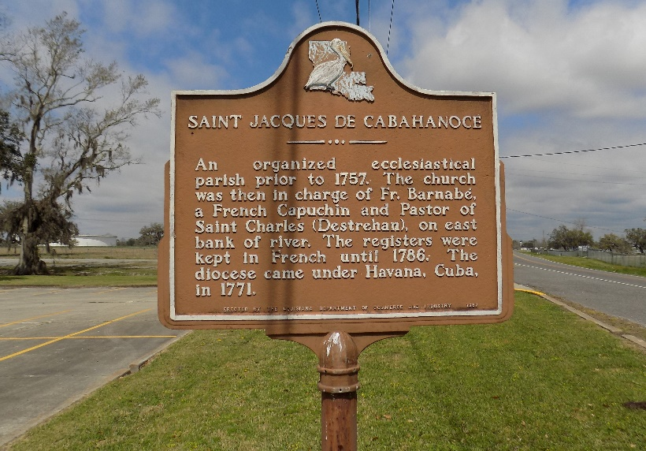

STEPHANIE WEBER EVANS: A loving mother and friend, she died Wednesday, Dec. 12, 2007 at Baton Rouge General Medical Center. She was 69, a native and resident of Vacherie, LA.
Visiting at St. James Catholic Church in St. James, La. from 8:00am to Religious Services at 11:00am Saturday conducted by Rev. Louis Oubre. Recitation of the rosary at 9:30am. Burial in the church cemetery.
Survived by 3 daughters and son in law, Angela and T.L. Barnett, Bridget Evans and Evelina Cohen. One son, Israel Evans, III; One brother, Raymond Weber, Sr.; 3 sisters in law, Delores Murray, Lisa and Helena Weber. Also survived by 7 grandchildren, 3 great grandchildren and a host of nieces, nephews, other relatives and friends.
Preceded in death by her husband, Israel Evans, Jr.; Parents, Beatrice Oubre Weber and John Weber, Sr. and a brother, John Weber, Jr.

Williams & Southall Funeral Home, Napoleonville, Louisiana
**

U.S., Social Security Applications and Claims Index, 1936-2007

Name Stephanie Ann Weber
Gender Female
Race Black
Birth Date 28 Sep 1938
Birth Place Vachine, Louisiana
Death Date 12 Dec 2007
Father John Weber
Mother Beatrice Oubre
SSN xxx
Notes May 1957: Name listed as STEPHANIE ANN WEBER; 26 Nov 1975: Name listed as STEPHANIE A EVANS

