Herman Joseph Falgoust
August 17, 1930 – August 24, 2023

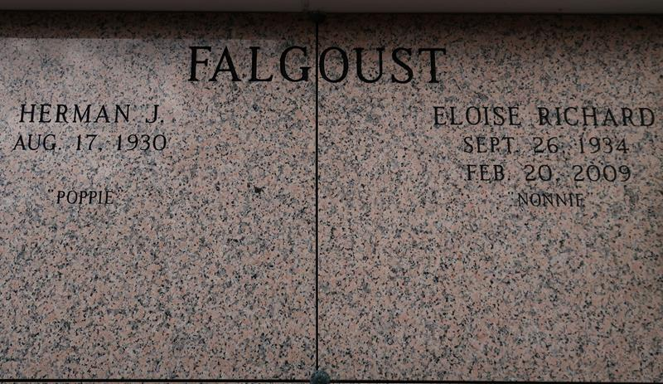

Herman Joseph Falgoust, age 93, a native of Vacherie and longtime resident of St. James, Louisiana passed away peacefully on Thursday, August 24, 2023. Herman, better known as "Poppie," was a loving father, grandfather, great grandfather, brother, uncle, and friend. He was a Sugar Cane farmer who farmed for many years. Herman enjoyed fishing and spending time at his camp.
He leaves behind to cherish his memory his four children, David M. Falgoust (Sarah), Dr. Susan F. Puyau (Dr. Michael), Paul N. Falgoust (Wendy), and Sybil F. Marcello (Frank); nine grandchildren, Mary N. Williams, Leigh Alexander, Eleanor Hallmark, Renee Stelzer, Jourdan Puyau, Aaron Falgoust, Austin Falgoust, Taylor Marcello, and Alana M. Templet; twelve great grandchildren, one sister, Gert F. Rousseau and two sisters-in-law, Myrna Falgoust and Mona Falgoust.
He is preceded in death by his wife, Eloise R. Falgoust; parents, P. Nelson and Gertrude Falgoust; three siblings, Preston Falgoust, Lester Falgoust, Ethel Martin and husband, Larry, and one brother-in-law, Roger Rousseau.
A visitation will be held at St. James Catholic Church on Wednesday, August 30, 2023 from 9:30am until Mass of Christian Burial at 12pm. Interment will follow in the church mausoleum.

The Advocate, Baton Rouge, Louisiana
Aug. 27 to Aug. 28, 2023

