Bertha Louise (Pierre) Favorite

December 2, 1927 – July 24, 2003

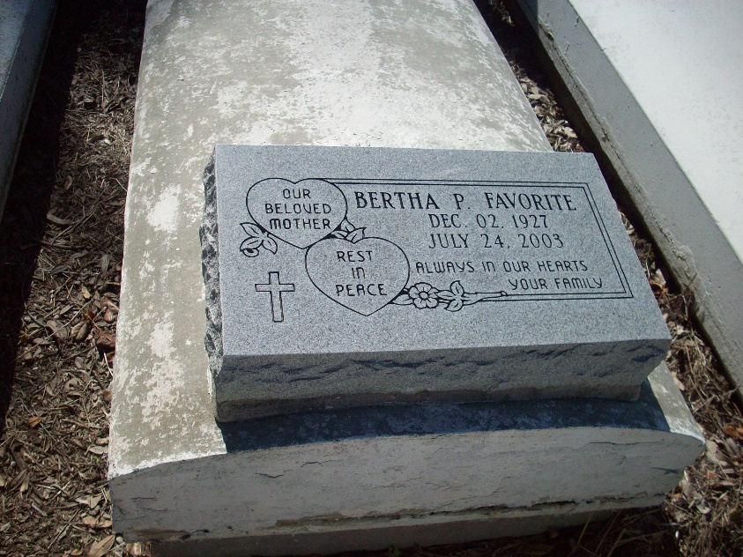

Photo by TMB

Bertha (Mom Bert) Louise Pierre Favorite, of Vacherie, LA, on Thursday, July 24, 2003 at Ochsner Foundation Hospital. Wife of the late Wilson J. Favorite, Sr. Daughter of the late Theophile and Blanche Pierre. Mother of Wilson Jr., James Donald, Anthony Ray, Kathleen Mary Favorite, Juliette F. Jasper of Vacherie, LA, Marce Rose Ann F. Washington of St. James, LA and Stephen Roy Favorite of New Orleans, LA. Mother-in-law of Eliane, Terese, Valerie Favorite, Angelios Washington, Sr. and Craig Jasper. Sister of Vivian Preyan, Mary Ann Rubin of St. James, LA, Theresa Austin of Hahnville, LA, Willimenia Trufant Joseph of Marrero, LA, Ernestine Allomon of California, Henry Pierre of Lafayette, LA, Freddie Pierre of St. James, LA, Ulysses Pierre of Darrow, LA, the late James and Elex Pierre. Also survived by 18 grandchildren, 8 great-grandchildren, a host of nieces, nephews, Godchildren, cousins and friends. A native of Welcome, LA and a resident of Vacherie, LA. Age 75 years.

Unknown source

\*\*

Favorite, Bertha " Mom Bert" a homemaker and resident of Vacherie, died at 4:55 a.m. Thursday, July 24, 2003, at Ochsner Foundation Hospital. She was 75 and a native of St. James. Visiting at St. James Catholic Church, St. James, from 8 a.m. to 10:45 a.m. Monday. Religious service at the church at 11 a.m. Monday, conducted by the Rev. Louis Oubre. Interment in church cemetery. Survived by three daughters, Kathleen Favorite, Juliette F. Jasper and Marie Rose Ann Washington; four sons, Wilson Jr., James Donald, Anthony Ray and Stephen Roy Favorite; five sisters, Vivian Preyan, Mary Ann Rubin, Theresa Austin, Willimenia Trufant Joseph and Ernestine Allomon; three brothers, Henry, Freddie and Ulysses Pierre; 18 grandchildren and eight great-grandchildren. She was preceded in death by her husband, Wilson Favorite; parents, Theophile and Blanche Pierre; and siblings, James and Elex Pierre. She was a member of Ladies Auxiliary 135, Rising Sun Society and Christian Mothers. The Baloney Funeral Home, Garyville, 985-535-2542, in charge of arrangements.

The Advocate, Baton Rouge, Louisiana; Sunday, July 27, 2003