Frances (Farace) Folse
November 7, 1919 – December 28, 2003
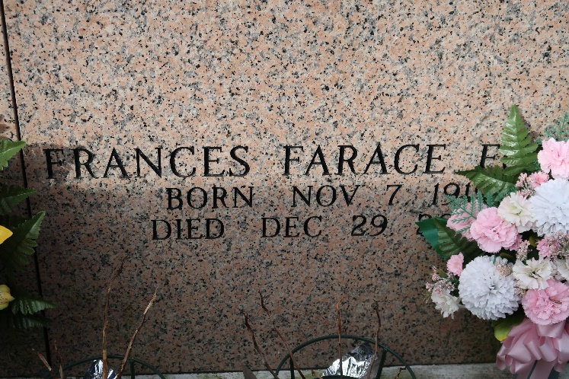

Francesca "Frances" Catherine Farace was born on 7 November 1919, in St. James, Louisiana, United States, daughter of Francesco Faraci and Caterina Maniscalco. She married Herbert Joseph Folse, Jr. on 23 January 1939, in Saint James, St. James, Louisiana, United States. They were the parents of Edward), Donald, Herbert, Jo Ann, Linda and Susanne, all deceased. Her siblings include Salvatore, Camille, and Samuel Sr.
Familysearch.org
**
Frances Farace Folse ''T.J.'' on Monday December 29, 2003 in St. James, LA. Mass of Christian Burial at 11 am on Friday at St. James Catholic Church, St. James, LA. Interment in St. James C.C. Mausoleum. Visitation at St. James Catholic Church in St. James, LA from 8am to 11am on Friday. Arrangements by Ourso of Donaldsonville.
Unknown source

