Herbert Joseph Folse Jr.
April 25, 1918 – October 4, 1987

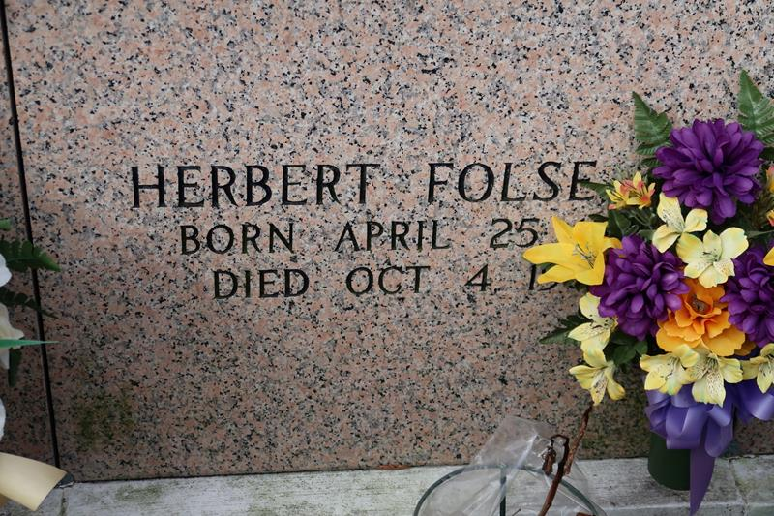

Herbert Joseph Folse, Jr., on Sunday, October 4, 1987 at 5:30 a.m. in Thibodaux, LA, husband of Mrs. Frances Farache Folse, of St. James, LA; son of the late Herber and Evelie Folse; father of Mrs. Norman (Jo Ann) Scioneaux and Mrs. Richard (Susanne) Webre, both of Vacherie, LA, Mrs. Charles (Linda) Louke, of Houma, LA, Mrs. Kenneth (Gwendolyn) Pitre, of St. Armant, LA and Herbert Folse, III, of Luling, LA; brother of Irene Becnel and Marie Stein, of Vacherie, LA, Lalee Benoit, of Chackbay, LA, Rita Glaviana, of Donaldsonville, LA, Frances Ockman, of Addis, LA and the late Westmore Folse; also survived by 14 grandchildren and 1 great-grandchild. Age 69 years, a native of Vacherie, LA and a resident of St. James, LA.
Relatives and friends of the family are invited to attend the funeral. A Mass of Christian Burial at 11 a.m. on Monday, October 5, 1987 at St. James Catholic Church. Interment in Church Cemetery. Visitation at St. James Catholic Church from 8:30 a.m. on Monday until service time. Arrangements by Ourso of Donaldsonville.

Unknown newspaper clipping

