Stephan Reeves Folse Sr.
July 8, 1971 – May 19, 2010

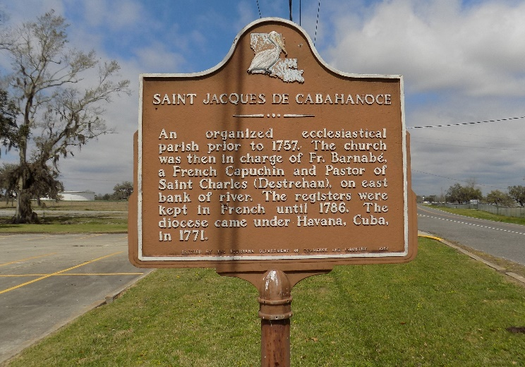

Stephan Reeves Folse, age 38, passed away on Wednesday, May 19, 2010. Born in Baton Rouge, he grew up in St. James and was a resident of Donaldsonville, he leaves behind his three children, Alexis, Reeves, and Jackson Folse; parents, Royley and Theresa Cagnolatti Folse; sister, Lisa Folse; brother, Michael Folse and his wife Kelly; maternal grandmother, Johnnie Reeves Cagnolatti; two nieces, Lauren Regira and Rayven Folse; two nephews, DJ and Chase Regira; and numerous aunts, uncles, and cousins. He is preceded in death by his maternal and paternal grandfathers, Bruce Cagnolatti and Royley Folse, Sr; and paternal grandmother, Terese Zeringue Folse. Stephan enjoyed hunting, fishing, cooking, watching football and playing Pedro. He was loved by many and will be missed by all.
The Advocate, Baton Rouge, Louisiana
May 21, 2010.

