Marsden Stevenson Geason
April 16, 1955 – July 8, 2021

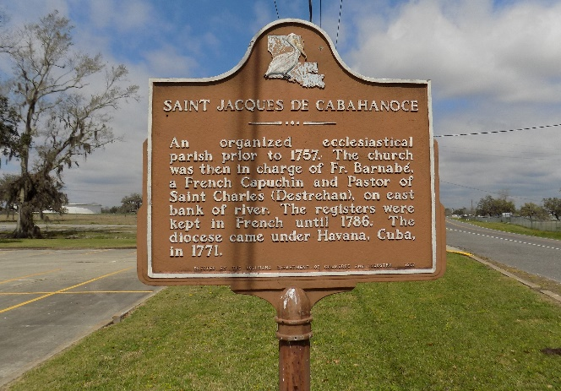

Marsden "Yello" Stevenson Geason, age 66, traded his earthly dwelling for his heavenly home on Thursday, July 8, 2021. Visiting 5-7 p.m., Thursday, July 15 at Demby & Son Funeral Home, Donaldsonville. Visitation continues 9 a.m., Friday, July 16 at St. James Catholic Church until Mass of Christian Burial at 11 a.m. Interment in the church cemetery.
Marsden leaves to cherish his loving memory siblings, Albert, Rev. Charles (Monica), Bernard (Joyce), Rev. Raymond (Rev. Jessica) Geason, Rev. Rita Sutherland, and a host of nieces, nephews, other relatives and friends.
He was preceded in death by his parents, Rev. Ernest and Marie "Anna" Geason, sibling Ernest Geason Jr., Bernice Landry, Lester Geason Sr., Earl Geason, and Victoria Steib; nephew Earl "Darnel" Geason.
The Advocate, Baton Rouge, Louisiana
July 14-16, 2021
**

Marsden Stevenson Geason, age 66, was born on April 16, 1955, traded his earthly dwelling for his heavenly home on Thursday, July 8, at 5:00 am. He was the ninth child of eleven siblings and the son of the late Rev. Ernest and Marie "Ann" Geason of St. James.
Marsden was affectionately known as "Yello." At a young age, Marsden was baptized in the catholic church by Father Stephen Schexnayder. He was a member of Saint James Catholic Church of Saint James, LA. Marsden was educated at Saint James High School in Saint James, LA, and a member of the class 1971. In his past time, Marsden loved socializing with friends and family. Yello had a heart full of compassion.
Marsden leaves to cherish his loving memory siblings; Albert, Rev. Charles (Monica), Bernard (Joyce), all of St. James, La., Rev. Raymond (Rev. Jessica) Geason of Gonzales, La., Rev. Rita Sutherland of St. James, La., Godson Raymond Geason Jr.; one sisters-in-law, one brothers-in-law, and a host of nieces, nephews, and friends.
He was preceded in death by his parents, Rev. Ernest and Marie "Anna" Geason, siblings, Ernest Geason Jr., Bernice Landry , Lester Geason Sr., Earl Geason, and Victoria Steib ; nephew Earl "Darnel" Geason.

Unknown source

