Edward Glaviana
October 5, 1944 – September 18, 2021

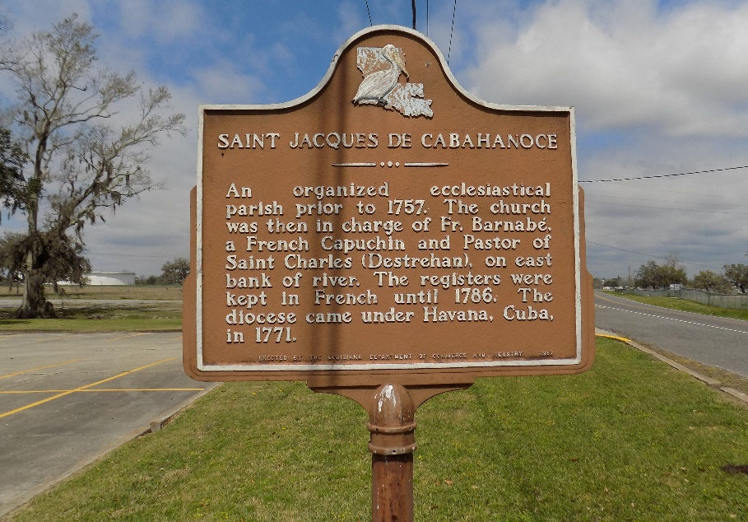

A ceremony celebrating the life of Edward "Johnny Beck" Glaviana will be held at 11:00 am on Tuesday, September 28, 2021, St James Catholic Church, St. James, LA. Visitation will begin at 9 am; interment will follow at the church cemetery.
Johnny Beck was a native of St. James, and a resident of Prairieville. He served with the U S Army. He passed away Saturday, September 18, 2021 at the age of 76 years.
He is preceded in death by his parents Lloyd and Emily Tabor Glaviana, and a brother Lloyd Glaviana Jr.
Survivors include his son Jason Glaviana, grandchildren Zachery and Ashley Glaviana, brothers Clyde Glaviana (Donna Faye), and Michael Glaviana, special friend Pam Moran; also survived by a host of nieces and nephews whom he loved dearly. Arrangements with Church Funeral Services (St. Amant, Louisiana).
The Advocate, Baton Rouge, Louisiana
September 23-28, 2021

