Antonio Glenn Harrison
February 1, 1961 – August 18, 2013

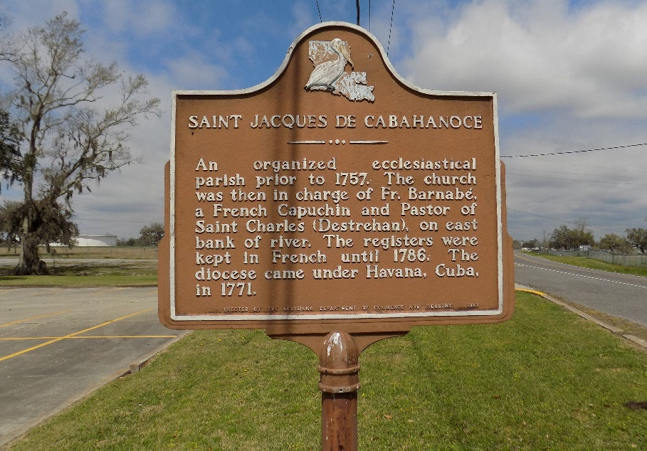

Antonio Glenn "Fly" Harrison passed away on Sunday, August 18, 2013, at the age of 52 years old.
Son of the late Audrey and Lawrence Harrison, Sr. Husband of Sandra Lewis Harrison. Father of Tramaine, Ebonea' and Ebonee' Harrison. Grandfather of Trenton Harrison. Also survived by a host of sisters, brothers, nieces, nephews, aunts, uncles, other relatives and friends.
Funeral services will be held at St. James Catholic Church, 6613 Highway 18, St. James, LA on Friday, August 23, 2013, at 11:00 a.m. Visitation will be from 9:00 a.m. until time of service. Father Louis Oubre will be officiating. Interment will be St. James Catholic Church Cemetery, St. James, LA.
The Advocate, Baton Rouge, Louisiana
August 20-23, 2013

