Elizabeth (Melancon) Haydel
January 27, 1924 – August 31, 2022

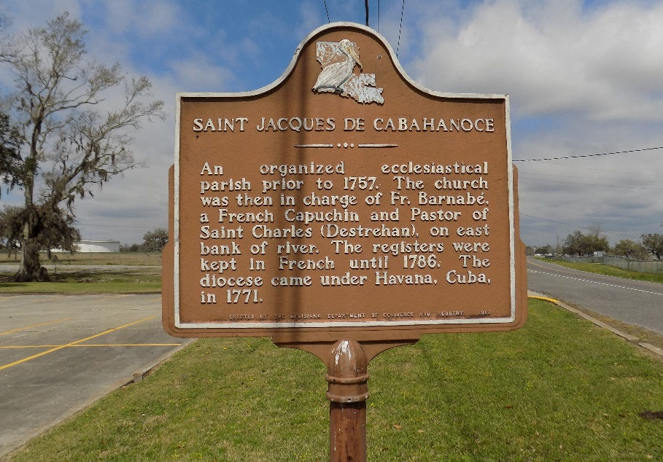

Elizabeth "Betty" Melancon Haydel, 98, a native of St. James and resident of Chateau de Ville in Donaldsonville, LA, passed away on Wednesday, August 31, 2022. She was the daughter of the late Dr. and Mrs. Claude Melancon. She was a devout Catholic and a loving mother to her son, the late Alvin Haydel, Jr.
She is survived by her daughter-in-law, Sheila Rodrigue Haydel of Thibodaux, LA, grandchildren, Scott Haydel of Houston, TX, Rebecca Haydel Pizzo (Bubba) of Thibodaux, LA and 3 great-grandchildren, Abigail, Joshua, and Jacob Pizzo. Loving sister to Corinne Bouquet of Gonzales, LA and Gerald Melancon (Judy) of Donaldsonville, LA.
Betty was preceded in death by her grandson, Jeffrey Haydel and her siblings, Yolande Bolline, Mildred Lands, Lucille Dolbear, Gertrude, Claude, Raymond, Edward, James, Roy, and Eugene Melancon.
Visitation will be at St. James Catholic Church on Monday, September 5, 2022 from 8:00 am until mass of Christian Burial at 10:00 am. Interment will follow in St. James Church Cemetery.
The Advocate, Baton Rouge, Louisiana
September 4, 2022

