Rogers J. Haydel
October 9, 1945 – May 4, 2001

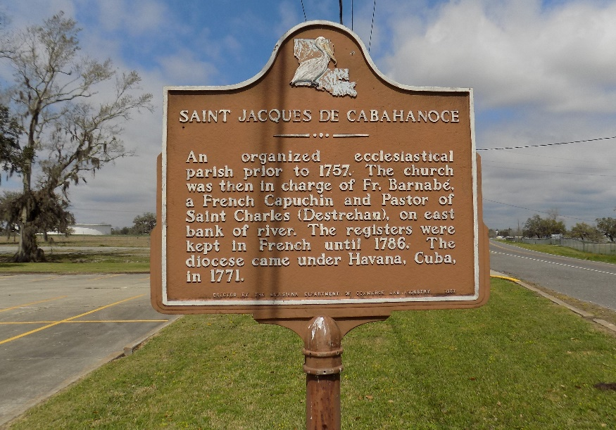

HAYDEL ST. JAMES – Rogers J. Haydel, 55, a native of Wallace and a resident of St. James, died May 4. He was the husband of Rosemary B. Haydel and father of Martha Batiste. He was also the son of the late Dalton and Priscilla Bethancourt Haydel and brother of Ora Lee Ferchaud, Gilba Marshall, Mary Ann Burrell, Lynda Pierce, Theophile Sr., Murry and Jerry Haydel and the late Ruby Becnel and Raymond Haydel. He is also survived by three grandchild-ren.
Services were May 7 at St. James Catholic Church, St. James, with interment at the church cemetery.
L’Observateur, LaPlace, Louisiana
Wednesday, May 9, 2001
**
U.S., Social Security Applications and Claims Index, 1936-2007
Name Rogers Joseph Haydel
Gender Male
Race Black
Birth Date 9 Oct 1945
Birth Place Edgard, Louisiana
Death Date 4 May 2001
SSN xxx
Notes Jul 1964: Name listed as ROGERS JOSEPH HAYDEL; 20 Jun 2001: Name listed as ROGERS J HAYDEL

