Joyce (Ambrose) Hazelwood
September 5, 1945 – July 19, 2023

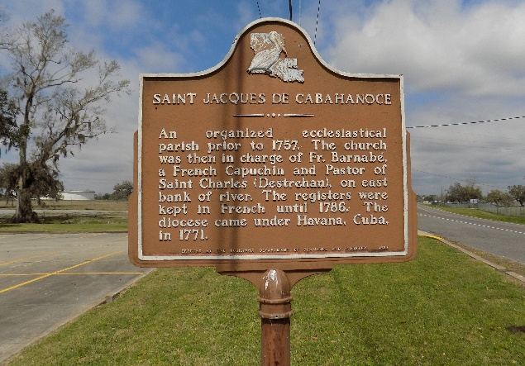

Our Almighty God of Heaven and Earth sent an Angel from his place of dwelling to be born to Joseph and Florestine Ambrose on September 5, 1945, in Chopin, LA (St. James, LA), and decreed her return on July 19, 2023.
Joyce was the loving daughter, and one of thirteen siblings that they had, and was the fifth child, being the second girl of four sisters, of which 1 preceded her at childbirth named Louise, and she also had nine brothers. She was born peacefully at home by a midwife.
Joyce attended Cedar Grove Elementary School and then went on to graduate from Magnolia High School, after which she went on to achieve her Bachelor's Degree of Science in Business Administration while attending Southern University A&M on May 31, 1968. Following that, she progressed her education by eventually receiving a Double Masters Degree in the Profession of Accounting and all while working for the United States Air Force as Head of Finances for DFAS at March Air Force base located in California, where she eventually went on to retire from serving our Service Members at home as well as abroad.
Joyce was lovingly called "Joyce Ann and Joycee" by her brothers and sisters, and "Peaches' (because she was so Sweet) by her niece Cindy and very near and dear friends. She was also known by Charlene as 'Cutie Pie' because she knew that she was the reason Why" (smile) and called "Mother" by Darlene. She will be missed beyond words by all of us present here as well as those that could not make it here today to witness her home going. Glenn T. Goudia and Joyce A. Ambrose Hazelwood, and formerly married name Goudia, only had two children. Their names are Charlene and Darlene Goudia.
She is survived by her two daughters that gave her ten beautiful grandchildren, as well as five great grandchildren. Of all 10, one preceded her in death: Anthony Paris Goudia, sunrose on January 15, 1988 and his sunset when our Lord and Savior received him by decree, on December 27, 2021. Charlene's children from oldest to youngest are Chalisa, Sade, Geovante, Devante, and Deondre. These are Joyce's grandchildren from Charlene as follows: Fredrick, Karl Jr., and Kai. Darlene's children from oldest to youngest are Anthony, Laurice, Luke, Aaron, and Lauren. These are Joyce's grandchildren from Darlene as follows: Annalise and Marques.
Joyce A. Hazelwood is survived by her twin daughters, Charlene and Darlene Goudia, from her first husband, Glenn T. Goudia of Algiers, LA; and all her grandchildren, to include the spouse of Geovante Reed (Taylor Reed), Spouse of Sade (Mr. R.) as well as her great grandchildren of San Diego, CA, Moreno Valley, CA, and Landstuhl, Germany. She is also survived by her brothers: Jesse Ambrose and Jeffrey Ambrose of New Orleans, LA; Jerome Ambrose (Lolita) of Vacherie ,LA; Joshua Ambrose of Saint James, LA; and Jacob Ambrose (Dr. Patrice Ambrose) of Lafayette, LA, two sisters: First Lady Jerralyn Ambrose-Bazile (Reverend Elvin Bazile) that we lovingly call the Bishop (smile) of Harvey, LA, and Dr. Janice Roussell, Pastor (Dwight Roussell).
She is preceded in death by her parents Joseph and Florestine Ambrose Sr., and siblings, Joseph Ambrose Jr., Louis "John Boy" Ambrose Sr., James Ambrose (wife Maxine Ambrose, and daughter Jaye Patrice), Jules Ambrose (wife Judith Ambrose that has also passed away) and her little sister, Louise Ambrose that passed away at her birth.
Mom had many accomplishments and worked very hard to raise us with all that Grandmo and Papa instilled in her and her siblings. She was a devoted Christian and loved the Lord. She made sure we never needed or wanted anything within reason. For that we are grateful and love her dearly. Growing up it was church, recreational activities, and arts and crafts. She drew beautifully and wrote poems eloquently. In closing Mommy, we will always miss you with our heart and souls. Rest beautiful mother, rest. Love Charlene and Darlene.
A Mass of Christian Burial will be held on Saturday, August 5, 2023, at St. James Catholic Church, 6613 LA-18, Saint James, LA 70086. Visitation will begin at 11AM with the Mass to follow at 1PM. Interment to follow at St. James Catholic Church Cemetery.

Treasures of Life Funeral Services, Gramercy, Louisiana

