Alice Heary
1916 – April 16, 2006

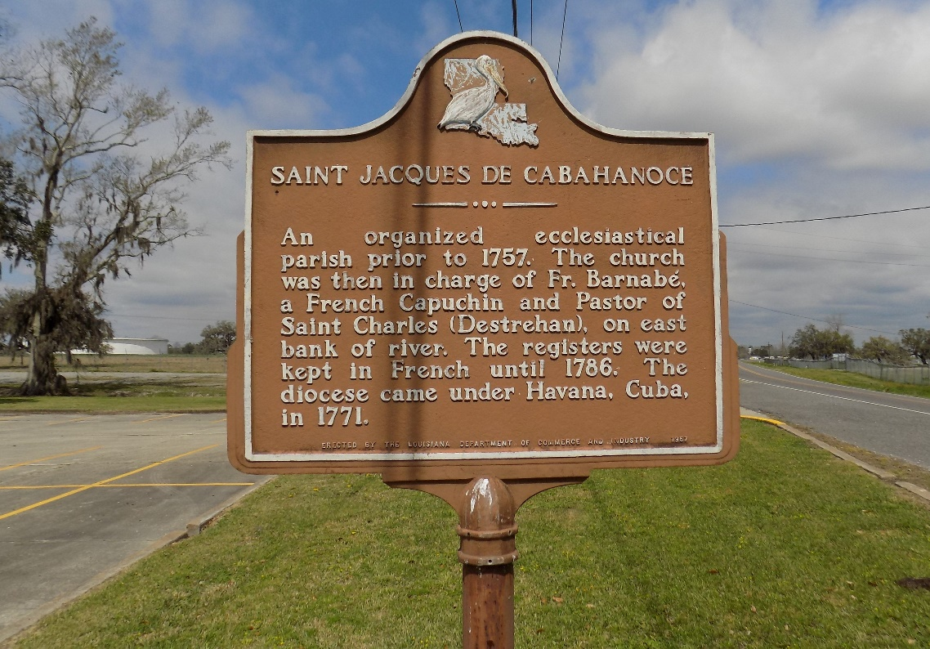

Alice Heary, of St. James, LA, passed away on Sunday, April 16, 2006.
Mother of Amelia Henderson, Lydia Stewart, Yvonne Green, Patricia Schexnayder, Barbara Poche and Betty Stewart. Sister of Aline, Sedonia Spencer, Elvenia Rodrigue, Janie Sutherland, Pheldine Monconduit and Lionel Spencer. Survived by 25 grandchildren, 47 great, 10 great great grandchildren. A native and resident of St. James, LA. Age 89 years.
Mass of Christian burial Saturday, April 22, 2006, 11:00 a.m. St. James Catholic Church, St. James, LA. Interment in the church cemetery. Visitation at the church after 9:00 a.m.

Times Picayune, New Orleans, Louisiana
April 20, 2006

