Amelia (Heary) Henderson
1933 – June 8, 2019

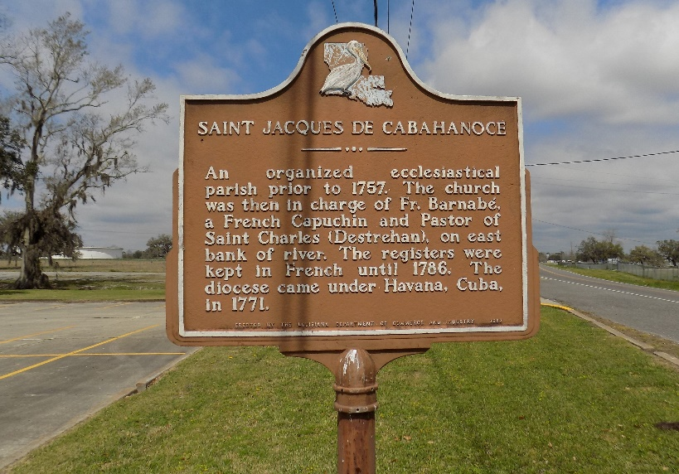

Amelia M. “Mea” Henderson departed this life on Saturday, June 8, 2019 at her residence in Donaldsonville, LA. She was 85, a native of St. James, LA.
Visitation on Thursday, June 13, 2019 at Williams and Southall Funeral Home, 101 Loop 945, Donaldsonville, LA from 2:00pm to 4:00pm. Visitation at St. James Catholic Church, St. James, LA on Friday, June 14, 2019 from 11:00am to Mass of Christian Burial at 1:00pm. Burial in the Church Cemetery.
Survived by 2 sons, Junius (Selma) Henderson, Jr.; Anthony (Janice) Henderson; 4 sisters, Lydia Stewart, Patricia Schexnaydre; Yvonne Green and Betty Stewart; 9 grandchildren; 14 great-grandchildren; a host of nieces, nephews, other relatives and friends.
Preceded in death by her husband, Junius Henderson, Sr.; parents, Louis and Alice Heary; son, Bernard Henderson; brother, Louis Heary; 2 sisters, Albemia Mayo and Barbara Poche; 2 grandsons, Jamone Henderson and Alfred Harvey, Jr.

Williams & Southall Funeral Home, Donaldsonville, Louisiana
**

U.S., Cemetery and Funeral Home Collection, 1847-Current

Name Amelia M. Henderson
Gender Female
Death Age 85
Birth Date 1934
Residence Place St. James, La.
Death Date 8 Jun 2019
Death Place Donaldsonville, La.
Obituary Date 11 Jun 2019
Obituary Place Donaldsonville, LA, USA
Parents Louis Heary; Alice Heary
Spouse Junius Henderson
Child Bernard Henderson; Anthony Henderson; Junius Henderson
Siblings Patricia Schexnaydre; Lydia Stewart; Albemia Mayo; Louis Heary; Barbara Poche; Betty Stewart; Yvonne Green

