Junious Henderson Jr.
October 11, 1955 – August 25, 2020

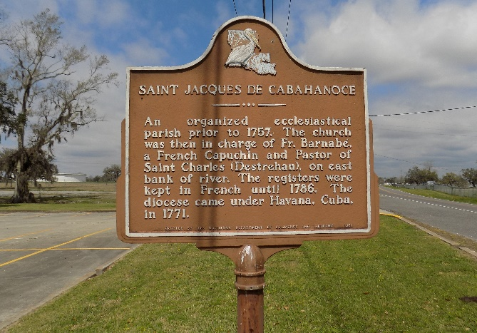

Junious “Kookie” Henderson, Jr. a resident of Napoleonville, LA and a native of St. James departed this life on Tuesday, August 25, 2020 at Thibodaux Regional Medical Center.
Visitation on Thursday, September 3, 2020 at Williams and Southall Funeral Home, 101 Loop 945, Donaldsonville, LA 70346 from 5:00pm to 7:00pm. A private Mass of Christian Burial on Friday, September 4, 2020 at St, James Catholic Church Cemetery at 11:00am. Burial in the church cemetery.
Survived by his wife, Selma N. Henderson; 1 son, Junious Henderson, III; 1 daughter, Chassidy Henderson; 1 brother, Anthony Henderson; 2 grandchild-ren; a host of aunts, uncles, nieces, nephews, other relatives and friends.
Preceded in death by his parents, Amelia and Junious Henderson, Sr.; 2 sons, Jamone Henderson and Alfred Harvey, Jr.; 1 brother, Bernard Henderson.

Williams & Southall Funeral Home, Donaldsonville, Louisiana
**

Junious Joseph “Kookie” Henderson from tree Reginald Douglas' Family Tree

Birth 11 Oct 1955 Lutcher, St James, Louisiana, USA
Residence 1986 Belle Rose, Assumption, Louisiana, USA
Death 25 Aug 2020 Thibodaux, Lafourche, Louisiana, USA
Father Junius Joseph Henderson (1913-1994)
Mother Amelia M. “Mea” Heary (1934-2019)
85796 People 5 Records 5 Sources

