Geraldine (Villavaso) Hill
1944 – April 3, 2014

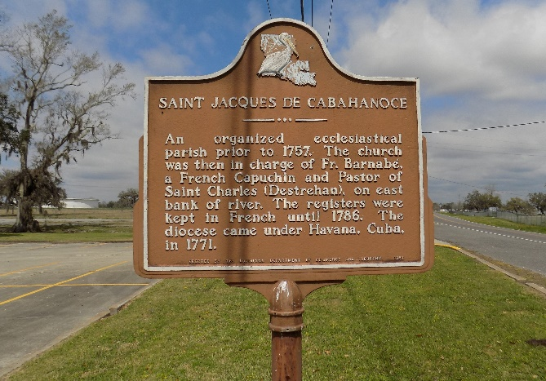

Geraldine Villavaso Robinson Hill, passed away on Thursday, April 3, 2014, at the age of 69 years old. Daughter of the late Mottress and Marie Villavaso. Wife of the late Lee Arthur Robinson. Mother of Catherine (Willie) Johnson of Inkster, MI., Thelma Cummings, Cynthia (Elray Singleton) Robinson-Singleton, Angela Robinson, Audrey (Galen Roy) Robinson-Roy and the late Rosa Lee Miller, and Mac Arthur Robinson. Also survived by a host of sisters, brothers, grandchildren, nieces, nephews, cousins, other relatives and friends.
Funeral services will be held at Mt. Zion Baptist Church, 107 Magnolia Ridge Road, Boutte, LA, on Saturday, April 12, 2014, for 11:00 a.m. Visitation will be from 9:00 a.m. until time of service. Pastor Raney Antoine will be officiating. Interment will be at St. James Catholic Church Cemetery, St. James, LA. A viewing will be held on Friday, April 11, 2014, at The Baloney Funeral Home, LLC., from 2:00 p.m. until 5:00 p.m.
The Times-Picayune, New Orleans, Louisiana
Apr. 8 to Apr. 11, 2014

