Herman Joseph Hymel
January 29, 1942 – November 28, 2014

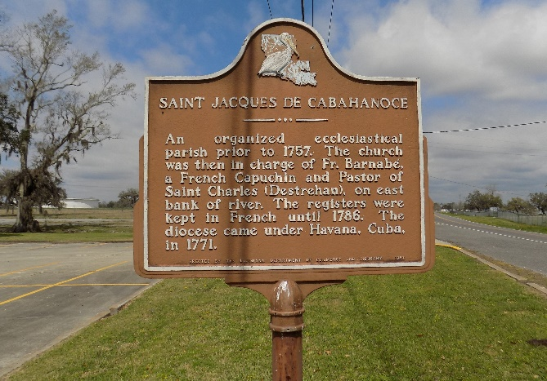

Herman Joseph Hymel, a native of St. James and resident of Thibodaux Healthcare Center for the past 5 years, passed away Friday, November 28, 2014 at the age of 72.
He was preceded in death by his parents, Jules and Lucella Loup Hymel; brothers, Kelsey P. Hymel and Warren P. Hymel.
He is survived by his brother and sister-in-law, Eddie J. and Grace Hymel; sisters and brothers-in-law, Audrey H. and Jimmie Becnel, Carlyn H. and A.J. Kliebert, Sylvia H. and Jack Bourgeois, Janet H. and Carroll Ponson, and Jane H. Rivere; sisters-in-law, Teen Hymel and Janice Hymel.
He was retired from Graugnard Farms after working for them for 40 years. When he was in good health he enjoyed St. James High sporting events, camp suppers, and the Senior Citizen's activities.
Visitation will be held at St. James Catholic Church in St. James, Tuesday, December 2, 2014 from 9:00 a.m. until a Mass of Christian Burial at 11:00 a.m. with Rev. Chris Decker, celebrant. Entombment will be in the mausoleum in the church cemetery. In lieu of flowers, masses are preferred.
The family would like to extend their sincere gratitude to Thibodaux Healthcare Center.

The Advocate, Baton Rouge, Louisiana
Nov. 30 to Dec. 1, 2014

