Joseph Gene Jackson Sr.
April 6, 1937 – August 13, 2020

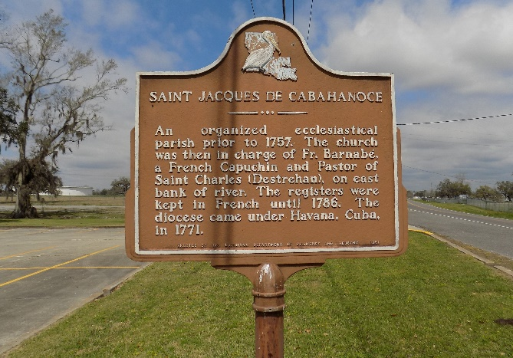

A gentle heart stopped beating and went to be with his Heavenly Father. Joseph Gene Jackson, Sr. peacefully entered eternal rest on Thursday, August 13, 2020. “Gene”, as he was affectionately known by many, was born on April 6, 1937 to the late Joseph and Ruby Winchester Jackson. He later met and married the love of his life Donna Jackson. Joseph loved his cars, eating good food and listening to music.
Left to cherish a lifetime of countless memories are his four children Jean (David) Marco, Joseph (Nancy) Jackson, Jr., Michael (Monica) Jackson and Troy (Geraldine) Bruce, one sister Mae Evely Johnson, eighteen grandchild-ren, sixteen great-grandchildren, and a host of nieces, nephews, cousins, other relatives and friends.
He was preceded in death by his wife Donna Jackson, parents Joseph and Ruby Winchester Jackson, and one sister Shirley Jackson Scott.
The family of Joseph Gene Jackson, Sr. would like to thank Hospice of Acadiana for the love and care their staff provided and Ms. Karen for going the extra mile and making sure all of his needs were met.
A graveside ceremony honoring the life of Joseph G. Jackson will be held Saturday, August 22, 2020 at St. James Catholic Church Cemetery, 6613 Highway 18, St. James, LA 70086.

Treasures of Life Funeral Services, Gramercy, Louisiana

