Ida Mae (Bazile) Jasmin
January 5, 1930 – June 23, 2020

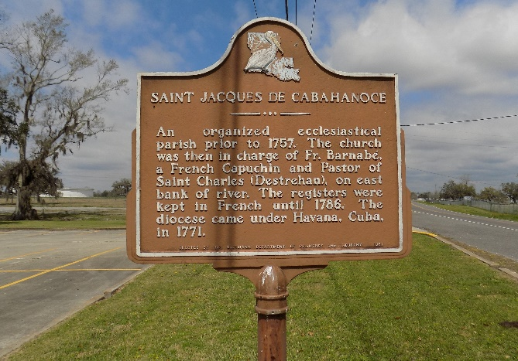

Ida Mae B. Jasmin departed this life on Tuesday June 23, 2020 at her residence in Vacherie, LA. She was 89 and a native of Vacherie, LA.
Visitation on Monday, June 29, 2020 at Williams and Southall Funeral Home, 101 Loop 945, Donaldsonville, LA from 4:00pm to 6:00pm. Mass of Christian Burial on Tuesday, June 30, 2020 at St. James Catholic Church at 1:00pm for immediate family. Mask are required. Burial in the church cemetery.
Survived by 7 sons, Lester Ketchens (Lena), Charles Ketchens (Gretchen), Michael Williams (Felecia), Patrick Jasmin, Anthony Jasmin (Joann), Julian Jasmin (Stella) and Terrence Jasmin (Monica); 1 daughter, Adrianne Octave (Kevin); 4 daughters in law, Deanine Frazier, Eileen, Germaine and Gladys Jasmine. 3 brothers, Curtis, Stanley and Clarence Bazile; 1 sister, Gennnive Treaudo; 49 grandchildren; a host of great-grandchildren, nieces, nephews, other relatives and friends.
Preceded in death by her husband, Joseph Jasmin; parents, Puliska and Joseph Bazile; 4 sons, Joseph, Jr., Timothy, Sr., Marvin and Rev. James Jasmin; 4 brothers, Junius, Sheldon, Herbert and Charles Bazile.

Williams & Southall Funeral Home, Donaldsonville, Louisiana
**

Ida Jasmin from tree Jasmin Family Tree

Birth 5 Jan 1930 Vacherie, St James, Louisiana, USA
Residence Vacherie, St James, Louisiana, USA
Death 23 Jun 2020 Vacherie, St James, Louisiana, USA
Spouse Joseph Jasmin (1920-2003)

