Whitney P. Jasmin
December 1, 1916 – September 4, 2008

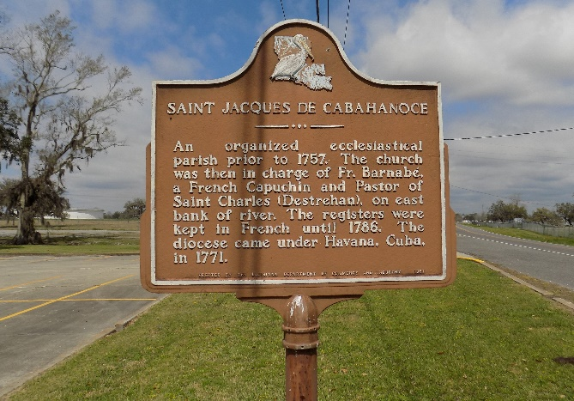

WHITNEY "PERK" JASMIN, SR. A U.S. NAVY VETERAN, HE DIED SEPT. 4, 2008 AT SOUTHWEST LOUISIANA WAR VWETERANS HOME IN JENNINGS, LA..HE WAS 91, A NATIVE AND RESIDENT OF VACHERIE, LA..

VISITING AT ST. JAMES CATHOLIC CHURCH IN ST. JAMES FROM 8:30AM TO MASS OF CHRISTIAN BURIAL AT 11:00AM WEDNESDAY CONDUCTED BY REV. LOUIS OUBRE. BURIAL IN THE CHURCH CEMETERY.

SURVIVED BY 3 SONS AND SPOUSES; WHITNEY, JR. AND FORMER WIFE YOLANDA; JOHN AND CARLYN, JAMES AND GAYNELL JASMIN; ONE DAUGHTER, AND FORMER HUSBAND, JUDY AND JOHN HARRISON; ONE BROTHER, CLINTON JASMIN, SR.; 11 GRANDCHILDREN,12 GREAT GRANDCHILDREN AND A HOST OF OTHER RELATIVES AND FRIENDS.

PRECEDED IN DEATH BY HIS WIFE, ONETA JASMIN; PARENTS, PHILOGENE AND VIRGINIA JASMIN; THREE SISTERS, ELODIE J. PAUL, BEULAH J. SORRELL AND MILDRED J. LASALLE; SIS BROTHERS, MARCUS, JOSEPH, MAXWELL, HENRY, GEOFREY AND CALVIN JASMIN.

HE WAS A MEMBER OF ST. JAMES COUNCIL #135 KNIGHTS OF PETER CLAVER AND AN USHER AT ST. JAMES CATHOLIC CHURCH.

Williams & Southall Funeral Home, Napoleonville, Louisiana

