David Joshua
1940 – June 2, 2024

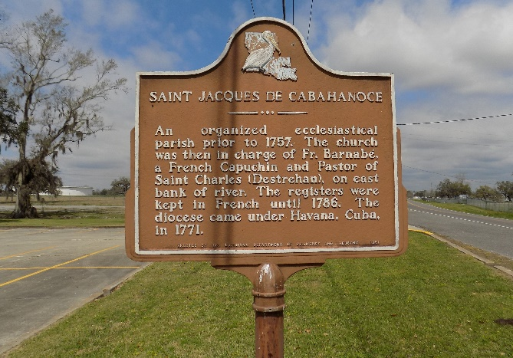

David Joshua, 84 years young, a native of Lemannville and resident of St. James, passed away at his home on Sunday, June 2, 2024. He was an alumnus of Southern University where he earned a Bachelor's Degree in Mathematics. He taught briefly at Booker T. Washington in New Orleans and Magnolia High School in Vacherie before starting a career at E. I. Dupont in Burnside as the Head Instrumentation Technican/Electrician. He retired there after over 40 years of service. He was also a dedicated deacon & videographer at Buena Vista Baptist Church.
Visitation will be held on Saturday, June 8, 2024 at Buena Vista Baptist Church, pastored by Rev. Dr. Joseph Coleman Sr. from 9:00 am to 11:00 am followed by the Celebration of Life Services at 11:00 am, officiated by Rev. Shedrick Smith, Sr. Burial to follow at St. James Catholic Church Cemetery.
David is survived by daughters: Marcia Joshua of Laplace & Bonnie Joshua Haydel of St. James; a sister: Eula Mae Joshua Murray of Gonzales; a brother: Rev. Sidney Joshua of New Orleans, LA; 3 Grandchildren: Myles David Haydel, Josef Bell & Brooklyn Haydel.
David is preceded in death by his wife, Joann Albert Joshua, a daughter: Wanda Joshua; a granddaughter: Tiah Brown; his parents: Namon Sr. & Florence Smith Joshua, 2 sisters and 6 brothers.

The Advocate, Baton Rouge, Louisiana
June 6, 2024

