Ethel Mae (Harris) Keller
1947 – March 10, 2017

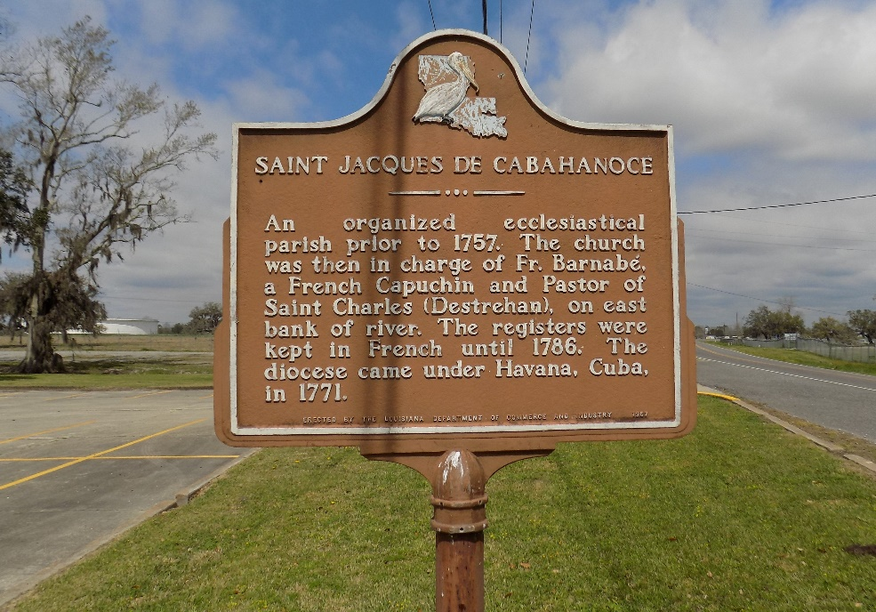

Ethel Mae Harris Keller, age 68, on Friday, March 10, 2017 at Thibodeaux Regional Hospital. Daughter of the late Daniel and Viola Harris. Wife of Morris Keller. Mother of Ann, Joseph and Laron (Angelle) Harris. Sister of Arthur (Ruby) Harris. Also survived by four grandchildren and three great grandchildren, other relatives and friends.

Relatives and friends of the family, also priests and parishioners of St. James Catholic Church are invited to attend a Mass of Christian Burial on Saturday, March 18,2017 from St. James Catholic Church, 6613 Highway 18, St. James, LA. Visitation begins at 9:00am followed by service time at 11:00am. Father Reuben Dykes, Celebrant. Interment in the church cemetery.

Treasures of Life Funeral Services, Gramercy, Louisiana

