Morris Keller
March 31, 1947 – April 9, 2024

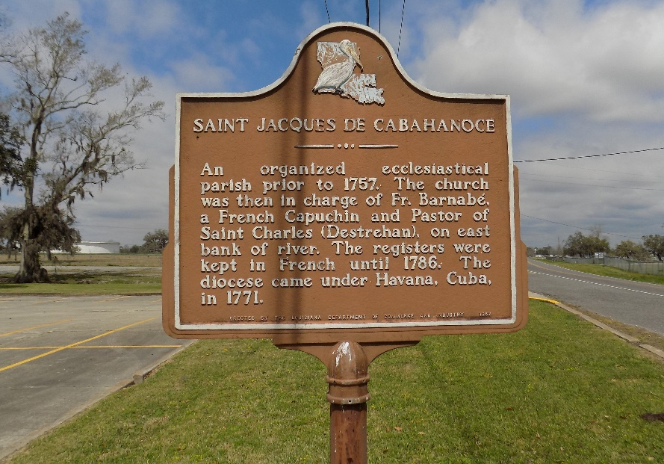

Mr. Morris Keller, a resident of St. James, Louisiana, passed away on Tuesday, April 9, 2024, at 9:15 am at Our Lady of the Lake Hospital in Baton Rouge, Louisiana. He was the son of the late Albertha Bright Temple and the late Joseph Keller.
Mr. Keller was a devoted member of St. James Catholic Church, where he demonstrated his humble Christian faith. Despite his failing health, he attended mass regularly until he was no longer able to do so. He was deeply devoted to his wife and children, always prioritizing their well-being. Known for his kindness and respectability, Mr. Keller touched the lives of many friends and family members throughout his life.
Until his retirement, Morris was employed by Graugnard Farms, where he exhibited a strong work ethic to support his family. His passing is mourned by all who had the privilege of knowing him.
Mr. Keller is survived by his daughter, Ann Marie Keller (Anthony) of St. James, LA; two sons, Laron (Angell) and Joseph Keller, of Donaldsonville, Louisiana; his granddaughters, Monique Keller and Maya Keller; grandsons, Anthony (Everia) Keller and Byron Keller; great-granddaughters, Aiyonna, Arianne, and Autumn Keller; step-grandson, Jailin Villavaso; great-grandson, Kyle Keller; two sisters, Mary (Larry) Bell of Houston, Texas, and Ruby (Arthur) Harris of New Orleans, Louisiana; two brothers, Jim (Dedra) Bright of New Orleans, Louisiana, and Ulysses (Audrey) Temple of St. James, Louisiana; his sister-in-law, Minister Gladys Jasmin of New Orleans, Louisiana; and a host of nieces, nephews, relatives, and friends.
Morris Keller was preceded in death by his wife, Ethel Mae Keller; mother, Albertha Temple; stepfather, Morris Temple; father, Joseph Keller; father and mother-in-law, Daniel and Viola Harris, Sr.; brothers, William Bright, Willie Temple, Sr., Eugene Keller, Sr., and Pastor James Jasmin; nephews, Eugene Keller, Jr., and Michael Keller; niece, Linda Keller; and a host of sisters-in-law and brothers-in-law.

Published on Legacy.com by Demby & Son Funeral Home, Donaldsonville, Louisiana
Apr. 15, 2024

