Lester Norman Ketchens, Jr.
October 2, 1951 – August 7, 2024

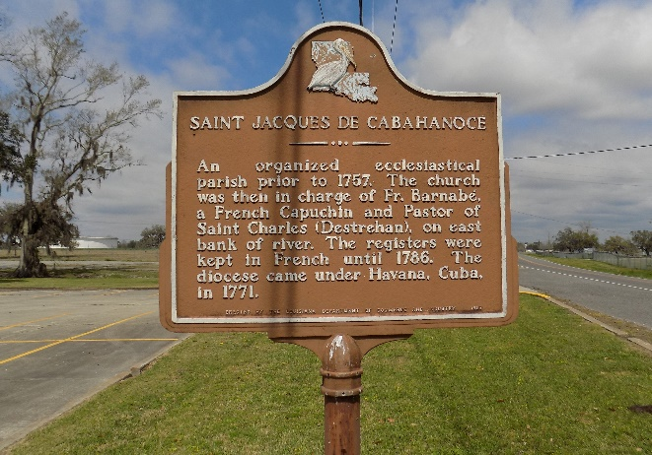

Lester Norman Ketchens, Jr. entered into his eternal life on Wednesday, August 7, 2024, at the age of 72, at Chateau D’Ville Rehab and Retirement Center in Donaldsonville, LA. Lester was born on October 2, 1951 to the late Ida Bazile Jasmin and Lester Norman Ketchens, Sr. and reared by Joseph Jasmin, Sr. He was a member of St. James Catholic Church. Lester graduated from the Job Corps in South Lake, Utah. He retired from St. James Parish Sheriff Office after serving for 12 years.
Lester will be deeply missed by his wife Lena, children Levan (Saabira) Ketchens, Daylun Poche, Javis (Carlene) Jackson, grandchildren Javin, Aenisha Mitt, Levante Ketchens, Keilah Jackson and great grandchildren Zae’Myune, Jeremiyah, Josiyah, Tyrrelle Mitt and Wynter Pierre. Brothers Charles (Gretchen) Ketchens, Anthony (Joann), Julian (Stella), Terrance (Monica), Patrick Jasmin, Michael (Felicia) Williams and sisters Adrianne (Kevin) Octave and Darlene (Khabir) Washeed. Sisters-in-laws Eileen, Germaine and Glayds Jasmin, Deaneene Fraizer, Shelia Landrum, Jeanette Treaudo, Paula Ketchens, Mavis Johnson (Robert), Sonja Jones and Eula Murray. Brother-in-law: David (Valerie) Stewart, Chester Joseph and Rev. Thomas (Loma) Walter. Uncles: Stanley, Curtis and Clarence Bazile. God children: Terrance Jasmin, Shanitra Jasmin, Gabriel Oubre Chestnut, Dwight Roussell Jr. and Je’Nada Ketchens. Friends: Florian Oubre III, Allen Weber, Warren Coleman, Clifton and Clinton Oubre and Wesley Hansley and a host of aunts, uncles, nieces, nephew, cousins and friends.
He was preceded in death by his parents Joseph and Ida Jasmin, Lester Ketchens, Sr., daughter Ronva Jackson, brothers Joseph Micheal Jasmin, Jr., Timothy Jasmin, Sr., Rev James Jasmin, Marvin Jasmin and Godparents Anna Lee Weber and Joseph Charles, his grandparents Puliska and Joseph Bazile. Lester Norman Ketchens, Jr. was a husband, a father and sibling who also became a “Family Historian and Patriarch”. Lester, the historian, evolved when he would listen to the conversations of his elders where he learned a lot about their character, workmanship and family values. It was this experience that led him to take on an interest in family history. He would share stories of those who are no longer with us, including their birthdates and date of departure from this life. In most cases he didn’t have to think about either date – he just knew it.
He was close to his family, always ready to share those traits that he learned from his elders as well as his own life experiences. It was at this point that he become “Our Family Patriarch”. The one that “we” looked up to for advice, compassion and family values.
A gathering of friends and family will be held Tuesday, August 13, 2024 from 3:00 to 5:00 p.m. at Treasures of Life Funeral Services, 315 E Airline Hwy. Gramercy, LA 70052. On Wednesday, August 14, 2024 a Mass of Christian Burial will be held for 11:00 a.m. at St. James Catholic Church at 6613 Hwy. 18 St. James, LA. Viewing will begin for 9:00 until 11:00 am, Father Mike O’Rourke officiating.

Treasures of Life Funeral Services, Gramercy, Louisiana
August 14, 2024

