Elmo Murry LeBeouf Sr.
July 3, 1941 – January 14, 2006

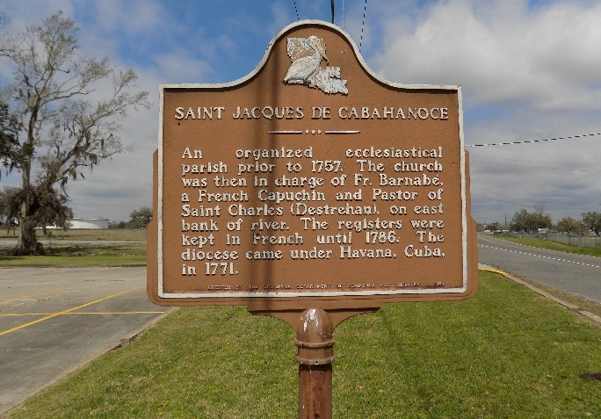

Elmo LeBeouf, Sr. In Natchez, Ms At 11:30 P.M., Saturday, January 14, 2006 While On A Hunting Trip. Son Of The Late Murry LeBeouf And Leah Folse LeBeouf. Husband Of Gail Brown LeBeouf Of St. James, LA. Father Of D'andre (Leon) Blouin, Leah (Jeffery Greenlee) Lebeouf, Elmo F. (Lashawn) Lebeouf III And Robert Narcisse, Whom He Reared. Brother Of Ella Harleaux, Donnaleah Carstarphen, Catherine L. Moore, Larry And Albert Lebeouf And The Late Robert Lebeouf. Grandfather Of Lauren, Logan And Leon Blouin IV And Sean Miles Lebeouf. Brother-In- Law Of Barbara And Diane Lebeouf, Cheryl And Joseph Gray, Joseph Carstarphen, Lincoln Moore And The Late Carolyn Lebeouf. Son-In-Law Of Henry Brown And The Late Lucy Peters Brown. Also Survived By Numerous Nieces, Nephews, Cousins, Other Relatives And Friends. Age 64.
Visiting At St. James Catholic Church, River Road, St. James, LA, on Saturday, January 21, 2006 From 9:00 A.M. Until Mass Of Christian Burial At 11:00 A.M. Conducted By The Rev. Louis Oubre. Burial Will Be Private.
Times Picayune, New Orleans, Louisiana
January 20, 2006
**

U.S., Social Security Applications and Claims Index, 1936-2007

Name Elmo Murry Lebeouf
Gender Male
Race Black
Birth Date 3 Jul 1941
Birth Place Donaldsonville, Louisiana
Death Date 14 Jan 2006
Father Murry E Lebeouf
Mother Leah H Folse
SSN xxx
Notes Jul 1958: Name listed as ELMO MURRY LEBEOUF; 16 May 1995: Name listed as ELMO FRANCOIS LEBEOUF; 08 Jul 2003: Name listed as ELMO F LEBEOUF

