Leah (Folse) LeBeouf
July 26, 1911 – January 20, 2003

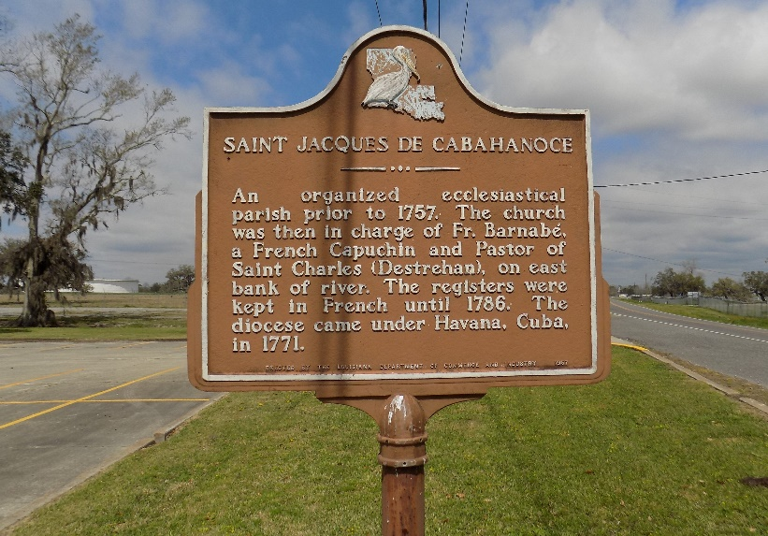

Leah Folse LeBeouf, at St. Elizabeth's Hospital, Gonzales, LA., at 5:55 A.M., on Monday, June 30, 2003.
Daughter of the late Joseph and Maria Hill Folse. Wife of the late Murry LeBeouf. Beloved mother of Elmo, Larry and Albert LeBeouf, Ella Harleaux, Donnaleah Carstarphen, Catherine L. Moore, and the late Robert LeBeouf.
Mother-in-law of Barbara, Gail and Diane Lebeouf, Joseph Carstarphen, Lincoln Moore and the late Carolyn Lebeouf. Sister-in-law of Dorthy and August Bajoie and Vivian Folse. Sister of the late Bennie, Joseph, Nathan and Odile Folse, Jestine Burbank and Catherine and Janie LeDuff. Also survived by 19 grandchildren, 13 great-grandchildren, nieces, nephews, cousins, other relatives and friends.
Visiting at St. James Catholic Church, St. James, LA., Friday, July 4, 2003, from 9:00 A.M. until Mass of Christian Burial at 11:00 A.M. conducted by The Rev. Louis Oubre. Entombment in Church Mausoleum.
She was an active member of The Ladies Auxiliary of The Knights of Peter Claver, 3rd Degree, Court #135, St. James and a member of Father John A. McShane, 4th degree, Chapter #23, Ladies of Grace, Knights of Peter Claver. Recitation of The Rosary at 10:00 A.M.
Times Picayune, New Orleans, Louisiana
July 3-4, 2003
**

Leah H Folse Le Beouf in Sherrell Montegue/Corse family tree

Spouse Murray E Lebeouf
Father Joseph Folse
Mother Marie E Hill Folse
Children Elmo Murry
Birth 26 Jul 1911 Texas, USA
Death Louisiana, USA
Residence 1935 St James, St James, Louisiana, USA

