Murry LeBeouf
August 3, 1908 – March 6, 2001

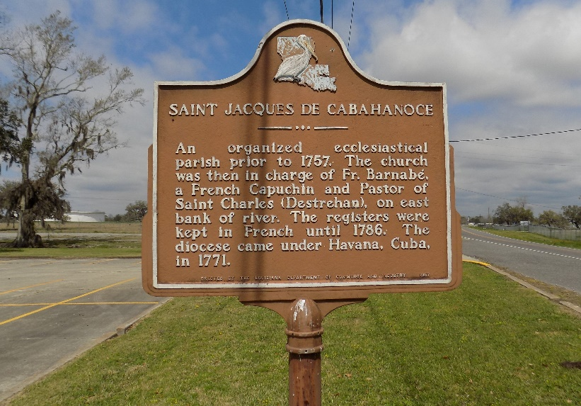

LeBEOUF ST. JAMES – Murry LeBeouf, 92, a native and resident of St. James, died March 6. He was the husband of Leah Folse LeBeouf, for 63 years, and father of Ella Harleaux, Donnaleah Carstarphen, Catherine Moore and Elmo, Larry, Albert and the late Robert LeBeouf. He was also the son of the late Florestan and Ella Tucker LeBeouf and brother of the late Alberta Dennis, Hazel Burke and Albert and Florestan LeBeouf. He is also survived by 19 grandchildren and 12 great-grandchildren. He was a retired sugar cane farmer.
Services are today at noon at St. James Catholic Church, St. James, with interment at the church mausoleum. Visitation starts at 9:30 a.m.

L’Observateur, LaPlace, Louisiana
Saturday, March 10, 2001
**

U.S., Social Security Death Index, 1935-2014

Name Murry Lebeouf
Social Security Number xxx
Birth Date 3 Aug 1908
Issue year 1955
Issue State Louisiana
Last Residence 70086, Saint James, Saint James, Louisiana, USA
Death Date 6 Mar 2001

