Johanna Kathleen Lee
1957 - March 27, 2006

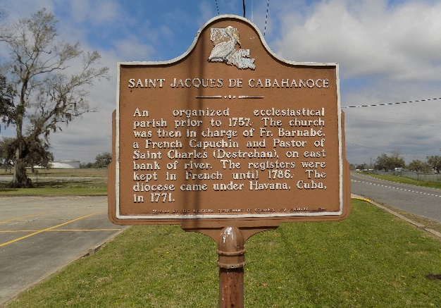

Johanna Kathleen Lee passed away on Monday, March 27, 2006, at the age of 48. She was a resident of Marrero, LA for over 40 years before being displaced following Hurricane Katrina to Houston, TX.
Loving mother of Leonard A. Lee. Beloved daughter of Altia J. Lee and the late Leroy W. Lee. Stepdaughter of Valentine Melancon and foster daughter of Willie Arso, Sr. Sister of Guy A. Lee, Beatrice Allen of Marrero, LA, Twila Collins of Modeste, LA and Mathilda Borne of Houston, TX. Sister-in-law of Darlene Lee and Carl Allen. Grandmother of Anisha Parker. Devoted and beloved aunt of Amber, Devanney, Guylynn and Guyia Lee and Guy Lampton. Niece of Irvin (Delores) Joseph, Nettie Andrews and the late James 'Bunny' Joseph, Jr. Devoted friend of Wade Hampton. Also survived by 2 godchildren, 4 great-aunts, 1 great-uncle, a host of nieces, nephews, cousins, other relatives and friends.
Relatives and friends of the family; also priest and parishioners of St. Joseph the Worker Catholic Church and Kaycee Auxiliary, The Secular Order of the Servant of Mary St. Anthony Pucci Community; pastors, officers and members of Truelove Full Gospel Ministries and all neighboring churches; employees of Volunteers of America, Knight-Celotex, TEI Truckers Express, Inc., Zachary / Monsanto, S & E Contractors of Houston, TX and clients of Lee's Income Tax Service are invited to attend the Funeral Mass of Christian Burial at St. Joseph the Worker Catholic Church, 440 Ames Blvd., Marrero, LA on Saturday, April 8, 2006 at 10:00 a.m. Visitation will begin at 8:30 a.m. Recitation of the Rosary will be at 8:45 a.m. Fr. Paul McQuillen, SSE, Celebrant. Interment St. James Catholic Church Cemetery, St. James, LA.

Times Picayune, New Orleans, Louisiana
April 8, 2006

