Arnold John Lowery
April 8, 1947 – September 24, 2024

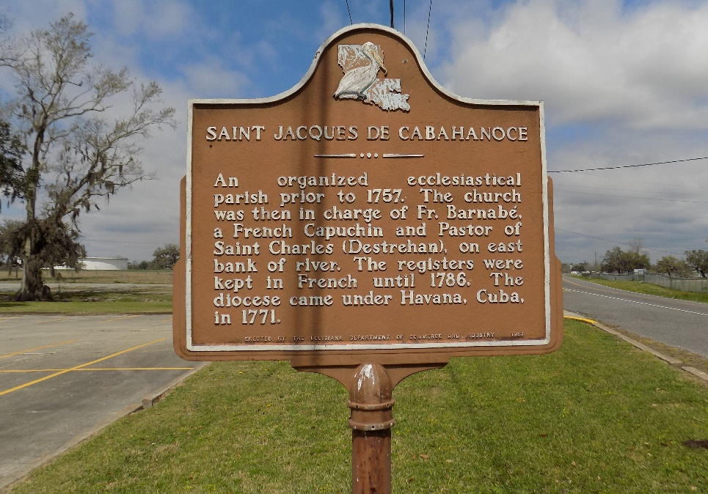

Arnold Lowery, a resident of Donaldsonville, LA, passed away peacefully at 6:40 pm at Baton Rouge General Hospital Bluebonnet in Baton Rouge, LA on September 24, 2024. He was 77 years old.
He is survived by his brothers, Leo (Barbara), Lionel Jr., Sidney, Valery (Betty), Ray (Annabelle), and Michael; 2 sisters, Lurlyn and Yolanda (Derrie). Arnold left to mourn a host of nieces, nephews, cousins, family and friends.
He is preceded in death by his parents, Lionel Sr. and Lucille Jones Lowery, 3 sisters, Carolyn Ann Lowery, Eura Mae Lowery, Sandra Lowery-Washington, and 1 brother Stanley Lowery.
Visiting 9 am on Friday, October 4, 2024 at St. Francis of Assisi Catholic Church, Donaldsonville, until Mass of Christian Burial at 11 am, Rev. Raphael Asika, Celebrant. Recitation of Rosary at 10 am. Interment in St. James Catholic Church Cemetery, St. James. Demby and Son Funeral Home in charge of arrangements.
The Advocate, Baton Rouge, Louisiana
Oct. 1 to Oct. 2, 2024

